NORTHERN GRIOTS NETWORK
northerngriotsnetwork.com
griotsnetwork@gmail.com

VISUAL17E OTTAWA GROUNDING

For immediate release: VISUAL17E OTTAWA celebrates Canada’s 150^{th,} with mural art, spoken word poetry, and a view to our beautiful future.

The Northern Griots Network (NGN) is thrilled to announce a celebration of Canada’s 150th anniversary with innovative poets and mural art on Saturday, December 9, 2017, 6-9 PM at Origin Arts & Community Centre, 57 Lyndale Ave, Ottawa. FREE ADMISSION!

This event introduces Ottawa to cutting edge collaboration through a dynamic poetic and visual celebration featuring some of Ottawa’s top spoken word artists, including Apollo the Child, King Kimbit, and Roua Ajied, with mural art created by brilliant visual artists including Kalkidan Assefa, Jason Gullo Mullins and Komi Olaf.

The mural art will be presented on Saturday, Dec. 9, 2017 at the famed Origin Arts & Community Centre, between 6-9 PM. The artists will engage in panel discussion exploring the creative grounding and collaborative development of the VISUAL17E project. The event will also feature spoken word performances of new creations from these acclaimed artists.

The artwork and performances mark the culmination of the NGN’s VISUAL17E project, a powerful fusion of spoken word poetry and mural art. Since its inception in February, the project continues to impact Ottawa’s arts landscape through vibrant creations.

VISUAL17E Ottawa is supported by the Ontario Arts Council, the Ottawa 2017 Arts, Culture and Heritage Investment Program (stewarded by AOE Arts Council, Ottawa Arts Council and Council of Heritage Organizations in Ottawa), the Origin Arts & Community Centre, the Ottawa Black Arts Kollective and House of Paint.

For more info, see www.northerngriotsnetwork.com or email griotsnetwork@gmail.com
Visit us at www.facebook.com/NorthernGriots or on Twitter/Instagram @northerngriots
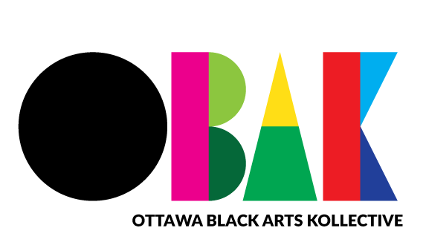
And see the Origin Arts and Community Centre https://www.facebook.com/theorigin57/
