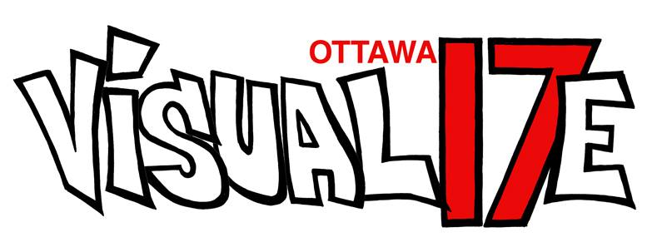
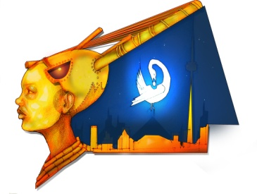
NORTHERN GRIOTS NETWORK
northerngriotsnetwork.com
griotsnetwork@gmail.com

VISUAL17E OTTAWA SHOWCASE
FOR IMMEDIATE RELEASE
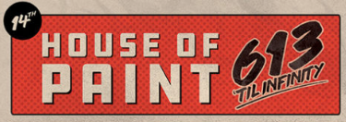
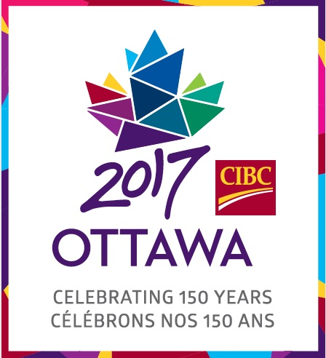
CONTACT INFO:
John Akpata
spokenwordguru@gmail.com
griotsnetwork@gmail.com
613-240-7550

VISUAL17E OTTAWA celebrates Canada’s 150th on August 26, 2017, at the House of PainT Festival, with spoken word poetry and visual art.

The Northern Griots Network (NGN), in partnership with House of PainT, is thrilled to announce a celebration of Canada’s 150th anniversary with a special showcase of spoken word and visual artists performing at the House of PainT main event on August 26, 2017,
at Brewer Park, Ottawa.

This special showcase features some of the National Capital’s top spoken word spoken word artists: Roua Aljied, King Kimbit, and Apollo the Child. The showcase also includes brilliant visual artists Jason Gullo Mullins and Komi Olaf. The spoken word poets are will perform at 3:00, 5:00 and 7:00 pm, at the main stage under the Dunbar Bridge.

The showcase forms part of the NGN project celebrating Canada’s 150th. VISUAL17E Ottawa is a powerful fusion of spoken word poetry and street art set to transform a visually underused city space into a vibrant art installation.

As one of the fourteen dynamic and varied experiences offered to residents and visitors next year as part of Canada’s 150th anniversary celebrations in the nation’s capital, VISUAL17E Ottawa is generously supported by the Ottawa 2017 Arts, Culture and Heritage Investment Program. The Program will highlight Ottawa’s diverse arts, culture and heritage offerings during Canada’s sesquicentennial celebrations.

For further information on the House of PainT main event: http://houseofpaint.ca/hop2016-event-schedule/

For more info on VISUAL17E Ottawa: www.northerngriotsnetwork.com
Facebook: www.facebook.com/NorthernGriots
Twitter/Instgram: @northerngriots
For info on the Arts Culture and Heritage Program: www.ottawa2017.ca/events/community-events/ach-program

