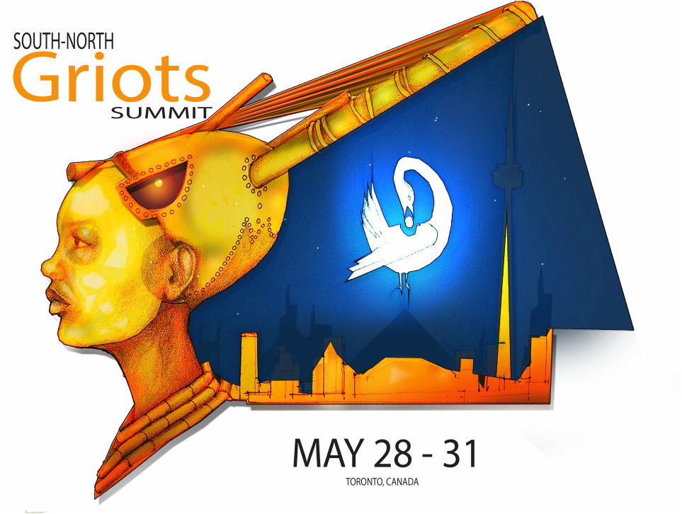
www.northerngriotsnetwork.com
griotsnetwork@gmail.com
Art Design by http://komiolaf.com/

WELCOME TO THE SOUTH-NORTH GRIOTS SUMMIT
The South-North Griots Summit (SNGS) in Toronto, May 28-31, 2015, is an international event that brings together spoken word artists and presenters of African Canadian and Caribbean heritage from across the Americas – including artists of Latin American, Indigenous, and Francophone heritage – and complements the Pan Am/Parapan Am Games (held in Toronto, July-August 2015. The group organizing the Summit is the Northern Griots Network (NGN), a collective led by four African Canadian spoken word artists and presenters: Motion, Dwayne Morgan, Eddy David and Anthony Bansfield. In presenting the Summit, the NGN is collaborating with the Nia Centre for the Arts.

The goal of the Summit is to connect a pan-continental community of practice in order to engage in performance and dialogue, through which we actively transform the narrative defining our art of spoken word. The dialogue centres on spoken word as an agent of social change, with the purpose of focusing on the development of spoken word poetry in order to increase opportunities and professional growth, expand the reach to domestic and international audiences, and promote and celebrate cultural diversity.

Activities include:
- Feature artist performances, as well as Groundation and open mic sessions for artists to exchange ideas, information, and works
- Workshops and panel presentations, free and open to the public, as well as a school visits program for students
- A special planning session for participants to discuss planned work on strategic initiatives as a follow up to the Summit

The Planning session includes discussion on planning one or more of the following initiatives:
- Produce a series of international exchanges between Canadian and international spoken word artists to increase audience and market development, career growth, and intercultural understanding.
- Produce a collection of spoken word videos to promote culturally diverse spoken word poetry using engaging, accessible media.
- Publish a series of papers on the instrumental and historic contributions of culturally diverse artists
- Produce a virtual repository of instructional materials utilizing spoken word poetry to engage youth and adapt to secondary school curricula in teaching literature and other subjects (e.g. creative writing, literacy, politics, media studies, and history).

SNGS participants include top spoken word artists and presenters from across Canada, the U.S.A., the Caribbean, South America, the UK, and elsewhere, including youth/community arts organizers and spoken word practitioners using innovative forms involving multiple arts disciplines. The main location is Harbourfront Centre, with one show in local performance venue, Lula Lounge, as well as several artist visits to local schools to conduct workshops. This seminal event offers artists broader markets and audiences to reach, in an international scope, and seeds dialogue and critical discourse towards fostering artistic excellence and innovation.
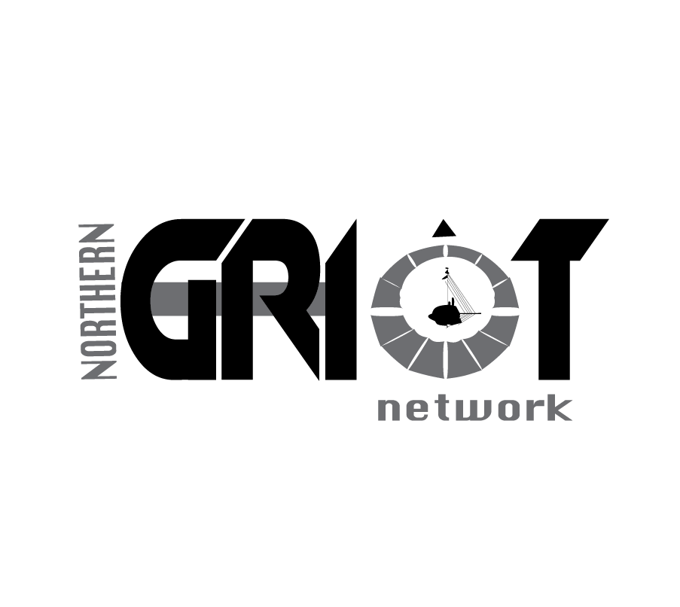
CURATORIAL VISION

The Northern Griots Network has produced the South-North Griots Summit (SNGS) as an international event bringing together premiere spoken word artists and presenters of African Canadian, Caribbean and culturally diverse heritage from across the Americas. The aim is to advance the development of Canadian spoken word by drawing on the best and the brightest to engage in discussion and display their skills for audiences to enjoy spoken word performance in its full artistic dimension: music, movement, rhythm, and voice.

Music, theatre and other performance forms are central to the role of griots in engaging audiences. Traditionally, they are storytellers/singers/musicians/poets/historians, and through their spoken words are the living memories of humankind. How has this African tradition traveled cross seas and south to north throughout the Americas? From the epics and praise songs sung by formal griots, through to blues narratives, dub missives, calypso subversives, and hip-hop provocatives, the poetic voice entertains and connects as a force of artistic communication, information, empowerment and transformation in our communities. Understanding what is constant and what has changed in this transition may be a way to better understand both where we have been and where we are going; for, as the griot reminds us, the world is old, but the future springs from the past.

Canada’s current spoken word poetry scene is flourishing and recognized as world class. It was built through the hard work, excellence and innovation of artists like Lillian Allen, Louise Bennett, Ayanna Black, and George Elliot Clarke, giants upon whose shoulders successive generations of spoken word artists and slam poets often unknowingly stand. The SNGS is a song in celebration of those accomplishments, and an exploration of how the seed planted in yesterday’s CELAFI and International Dub Poetry Festival is grown today to link Caribbean innovators whose dub poetry and rapso shape dancehall and soca with their techniques and tempos, with award-winning Canadian spoken word playwrights and ground-breaking impresarios putting poetry in motion when sisters/brothers speak, with US lyricists rocking Nuyorican, Def Poetry Jams and Apollo stages to bring a Jessica Care Moore to global acclaim.

Through these linkages, gathering brilliant new world spoken word organizers and artists to learn from one another, showcase talents, listen to and speak with youth, and chart a way forward, we look to reach higher heights, to rediscover a greatness that will live so forcefully in the minds of generations to come that it will never be lost.

— SNGS Coordinating Committee

South-North GriotS Program-AT-A-GLANCE
THURS, MAY 28 | FRI, MAY 29 | Sat, MAY 30 | SUN, MAY 31
 | NGN SCHOOL VISITS  Student Workshops  Lakeside Terrace/MBCS  10:00 AM– 11:30 AM | Opening Keynote  Studio Theatre  9:00 AM – 10:00 AM | The Griot Impact on the Contemporary Diaspora  MBCS  Poetics Pan Americas  Miss Lou Room  10 AM – 12:00 PM
 | NGN SCHOOL VISITS  Student Pan & Poetry Lakeside Terrace  12:30 PM – 2:00 PM | Learn Out Loud: Spoken Word & Education  Marilyn Brewer Community Space (MBCS)  Career Development: Taking Care of Business  Studio Theatre  Building Blocks: The Word on Community Engagement  Loft 1  10:30 AM – 12:00 PM
 | Planning/Orientation  Lakeside Terrace  4:00 PM – 6:00 PM | Nia Centre for the Arts Presents: Poets with Purpose  MBCS  12:30 PM – 2:00 PM | One Mic/Groundations  Brigantine Room & Tent  12:30 PM – 1:30 PM
Speak the Change! Spoken Word & Social Activism
Studio Theatre
Spoken Word Fusion
MBCS
Youth InterActive Co-creation Workshop
Loft 1
2:30 PM – 4:00 PM
Presenter Forum
MBCS
4:30 PM – 6:PM
Meet and Greet  LULA LOUNGE  7:00 PM – 8:00 PM | ACTION! Stage to Screen:  Spoken Word in Film/Video  Studio Theatre  6:00 PM – 7:00PM | ACTION! Stage to Screen:  Spoken Word in Film & Video  Studio Theatre  6:00 PM – 7:00 PM | Telling Our Story  Closing Keynote  Studio Theatre  2:00 PM – 3:30 PM
In the Beginning *  LULA LOUNGE  8:00 PM –11:00 PM | The Griots Lounge *  Brigantine Room  8:00 – 11:00 | Spoken World: Features *  Brigantine Room  8:00 PM –11:00 PM | SNGS Post Lime  Location TBC  5:00 PM –7:00 PM
SHADED ACTIVITIES INVITATION ONLY / STARRED ACTIVITIES (*) TICKETED / ALL ACTIVITIES @ HARBOURFRONT UNLESS OTHERWISE NOTED.

SOUTH-NORTH GRIOTS SUMMIT PROGRAM OF ACTIVITIES

THURSDAY, MAY 28

In the Beginning
Thursday, May 28, Lula Lounge, 1585 Dundas West, 8:00 – 11:00 PM

Featuring: Adrian Green (Barbados), Britta B (Toronto), El Jones (Halifax), Hyf the GypsySun (Ottawa), Dasha Kelly (Milwaukee), Winston Farrell (Barbados), and Emerson Alcalde (Brazil)

The word gives shape to the shapeless, forms the world, and brings reality into being. Fittingly, to begin the Summit, the Northern Griots Network, in collaboration with Up From the Roots, Lulaworld Festival, and the International Festival of Authors, present sensational spoken word artists from Canada, Latin America, the US, and the Caribbean to spark things off with a scintillating series of spoken word sets. Live music adds to the dimension in this venue tailor made for tropical beats and a roster of versatile vocalists who can ride a rhythm as well as slam.

Prior to the show, a meet-and-greet gathering, from 7:00 -8:00 PM and open to all, will offer the opportunity to informally mingle, share stories and ideas, and get to know the exceptionally talented people - artists, organizers, presenters, writers and cultural activists – gathered in Toronto for this unique event.

ONGOING

Artist Marketplace
Friday, May 29: 6 pm - 10pm / Saturday, May 30: 9am – 11pm / Sunday, May 31: 9am - 4pm, Harbourfront Bays

The Artist Marketplace will make available print publications of the talented roster of international spoken word poets participating in the Summit, as well products like CDs and DVDs featuring their work. You can even catch up with your favorite artist for a signed copy!

FRIDAY, MAY 29

Northern Griots School Visits
Friday, May 29, Harbourfront, 10:00 AM – 2:00 PM

A special NGN/Harbourfront School Visits co-presentation for students from registered schools only.

NGN Spoken Word Workshop (10:00 AM – 11:30 PM)

Presented in conjunction with the Harbourfront School Visits Program, this hands-on workshop provides an opportunity for high school students to enjoy spoken word performances by some of the top talents in the word, and learn from experts in delivering fun, interactive workshops.

NGN Pan and Poets Showcase (12:30 – 2:00 PM)

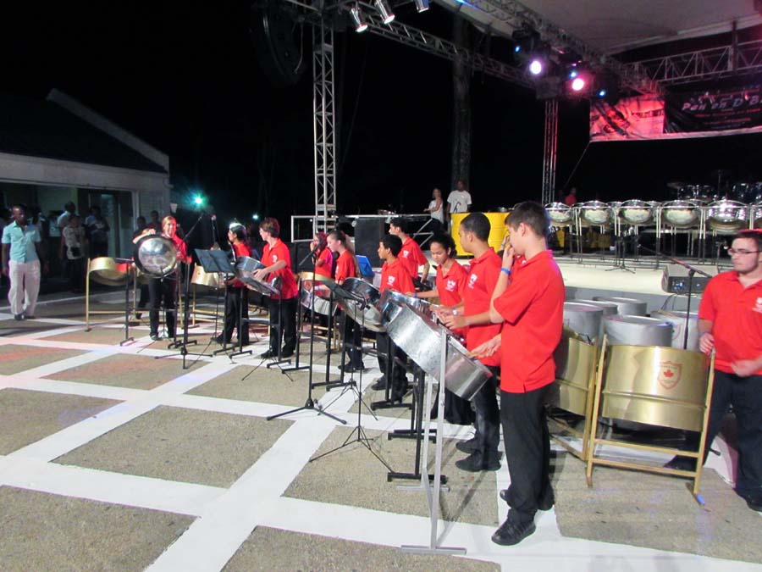
Featuring: Ahmed Knowmadic (Edmonton), Dasha Kelly (USA), El Jones (Halifax), and Spin Toronto), with special guest steel pan players from Trinidad and Tobago, the Maple Leaf International School Pan Ensemble.

As an instrument that is distinctly symbolic of the rich culture of Trinidad and Tobago and global in its popularity, the steel pan, like spoken word, is a vibrant contemporary artistic practice that engages youth and those of all ages in creative expression.

Accordingly, this performance is a combined musical/poetic presentation of steel pan and spoken word artists, featuring the artists facilitating the morning workshops.

The Maple Leaf International School Pan Ensemble is an extra-curricular group meeting twice a week after school, to practice and develop pan technique and appreciation. The students range from beginner to intermediate, with a few approaching a more advanced level. The music program at Maple Leaf teaches a Canadian curriculum while using steel pan as the performance medium. Pan is a versatile instrument lending itself well to all genres, and students learn a range of music, from classical to top 40. The band is presented in conjunction with Takestock as part of its e-pannists Exchange.

Summit Planning/Orientation Session
Friday, May 29, Harbourfront, Lakeside Terrace, 4:00 – 6:00 PM

This is a special planning session to meet other participants, review the Program, answer any questions, and generally provide an orientation to the Summit. As well, it is an opportunity to discuss ideas for a follow up to the Summit in terms of collaboration on future spoken word initiatives at a national and international level, including the following:
- Produce a series of exchanges between Canadian and international spoken word artists to grow audience and markets, careers, and intercultural understanding.
- Produce a collection of spoken word videos by Canadian artists, to promote culturally diverse Canadian spoken word poetry using engaging, accessible media.
- Publish a series of papers on the instrumental and historic contributions of culturally diverse artists to Canadian spoken word poetry, including online presentations.
- Produce a virtual repository of instructional materials utilizing spoken word poetry to engage youth and adapt to secondary school curricula in teaching literature and related subjects

Action! Stage to Screen: Spoken Word in Film & Video
Friday, May 29, Harbourfront, Studio Theatre, 6:00–7:00 PM
A special presentation of innovative collaborations of videographers and spoken word artists, this screening features a range of national and international spoken word video shorts by artists such as Dwayne Morgan, Motion, Ian Keteku, and nth digri.

The Griots Lounge
Friday, May 29, Harbourfront, Brigantine Room, 8:00 – 11:00 PM

Featuring: Knowmadic, Andrea Thompson, Eddy Garnier, Kym Dominique-Ferguson, Mahlikah Aweri, Shauntay Grant, Scruffmouth, Tanya Evanson
This culturally rich performance feature artists from across Canada and artists with Indigenous roots, in an exploration of the styles, approaches and themes that reflect the African influence of the griot tradition in Spoken Word, as well as the impact of the traditions of the First Peoples of the Americas. Manifesting how cultural roots from Taino to Creole, Maroon to Seminole have impacted the evolution of new modes of expression, like Nation Language, this showcase takes its cue from legendary dub poet Louise Bennett and the legacy of the Toronto Dub Poets Society.

SATURDAY, MAY 30

Opening Keynote
Saturday, May 30, Harbourfront, Studio Theatre, 9:00 – 10:00 AM

Featuring: opening presentation by griot Cheka Katenen, and keynote address by George Elliott Clarke
Toronto's Poet Laureate and award-winning author and playwright, George Elliott Clarke, delivers a special address to kick-off the South-North Griots Summit and stimulate thought around what this special event means for the past, present and future of spoken word in Canada and abroad. As well, the opening will feature a dynamic presentation from griot Cheka Katenen, aka the Snow Griot, an international recording artist from Guinea and currently based in Toronto.

Learn Out Loud: Spoken Word Arts & Education
Saturday, May 30, Harbourfront Studio Theatre, 10:30 AM – 12:00 PM

Panelists/Presenters: Dasha Kelly, John Akpata, Deonte Osayande, Motion
Education is changing! All over the globe, educators are realizing the need for cutting edge approaches to culturally relevant education in order to reach and teach learners at all levels. This session will feature a discussion of real-life models and practical techniques, as well as pedagogical approaches, in designing and delivering activities that engage learners through culturally diverse spoken word form and content. Topics such as Teaching Spoken Word, the Griot in the Classroom, Spoken Word and Learning Styles, and New Approaches for Arts Educators will equip artists with the tools to present their work in schools, post secondary institutions, alternative educational and community settings.

Career Development: Taking Care of Business
Saturday, May 30, Harbourfront Marilyn Brewer Community Space (MBCS), 10:30 AM–12:00 PM

Panelists/Presenters: Amani, Dwayne Morgan, Jamaal St. John, Quentin Vercetty, Tanya Evanson, Eddy DaOriginalOne
Marketing, branding, touring, publishing, promotion, artist development, building a career: this panel presentation will explore how spoken word artists are not only living for their art, but making art for a living. The session will include info on models and approaches used by spoken word entrepreneurs to develop events, products, and a range of career opportunities.

Building Blocks: The Word on Community Engagement
Saturday, May 30, Harbourfront Loft 1, 10:30 AM–12:00 PM

Panelists/Presenters: Mahlikah Aweri, Jaydahmann, Letecia Rose, Mtima Solwazi, Ahmed Knowmadic
How do we build our communities and mobilize our voices, one word at a time? “Building Blocks” features spoken word artists and presenters from across the globe, who have expertise in community development and youth engagement. They will join community workers from organizations like Nia Centre, creative leaders and artists, to discuss the arts as a pathway to engage, empower and heal our diverse communities, and share experiences, challenges, techniques and results.

Spoken Word Fusion
Saturday, May 30, 2015, Harbourfront, MBCS, 2:30 PM – 4:00 PM

Panelists: Kat Francois, Winston Farrell, Rachael Collymore, Kym Dominique-Ferguson
Featuring a discussion of the fusion of spoken word with dance, theatre, music, performance art, and other practices, this workshop will draw from the experience and insights of artists and presenters whose interdisciplinary work has pushed boundaries. In the vein of Griot practice, these innovators have embraced a range of expressive media to add dimension to their work in captivating audiences with their stories.

Nia Centre for the Arts Presents: Poets with Purpose
Saturday, May 30, Harbourfront, MBCS, 12:30 – 2:00 PM

Featuring: David Delisca, Lola Bunz, Quentin Vercetty, Randell Adjei, Griotz Road, Whitney French, Krystle Chance, Jaydahmann
The emerging artist showcase features the explosive talent of the now generation spoken word poets, lyricists and emcees, the future of the Griot legacy. This is a co-presentation with Nia Centre for the Arts, an organization that supports, showcases and promotes an appreciation of arts from across the Diaspora. Nia Centre fundamentally believes in showcasing art for the purpose of human development, and that art is a powerful tool to encourage growth and progress.

Speak the Change! Spoken Word & Social Activism
Saturday, May 30, 2015, Harbourfront, Studio Theatre, 2:30 – 4:00 PM

Panelists/Presenters: El Jones, Jessica Care Moore, Scruffmouth, Yasus Afari, Spin

As we witness a groundswell of resistance to injustice, manifest in contemporary activism across the globe – whether it’s street protests in Rio, Ferguson, or Montreal, with movements like Idle No More or Occupy– we hear spoken word artists joining the fray and giving voice to expression of dissent and hard questions that prod the propaganda machines, rub ruling elites the wrong way, and pose problems for power structures. This panel features news and views of artists who, in poetry and frontline involvement, address matters such as poverty, incarceration, discrimination, and human rights, on a local and global scale. It is a place to speak freely, as we consider the relationship between spoken word and social activism.

Youth InterActive Co-creation Workshop
Saturday, May 30, Harbourfront, Loft 1, 2:30-4:00 PM

Facilitators: David Delisca, OpenSecret, Whitney French

In collaboration with Nia Centre for the Arts, the South-North Griots Summit presents a special session with a discussion of expressive styles and hot topics expressed by youth through spoken word and through innovative, contemporary work with related forms, e.g. music, film and video, new media, dance, and theatre.

Presenters Forum
Saturday, May 30, Harbourfront, MBCS, 4:30 AM – 6:00 PM

Panelists: Kym Dominique-Ferguson, OpenSecret, Hyf the GypsySun, Scruffmouth, El Jones, Mtima Solwazi, Yasus Afari, Randell Adjei, Dwayne Morgan, Kat Francois, Tuggstar, Rachael Collymore, Dasha Kelly
This unique forum will involve a roundtable of national and international spoken word presenters who will discuss success stories, challenges, best practices, and networking opportunities in building infrastructure and developing their careers and those of the artists they present.

ACTION! Stage to Screen: Spoken Word in Film & Video
Saturday, May 30, Harbourfront, Studio Theatre, 6:00 – 7:00 PM

A special presentation of innovative collaborations of videographers and spoken word artists, this screening features a range of national and international spoken word video shorts. Performers include Toronto's Dwayne Morgan and Motion Live, Ian Keteku from Calgary and various international poets.
Spoken World: Features
Saturday, May 30, 2015, Harbourfront Centre, Brigantine Room, 8:00-11:00 PM
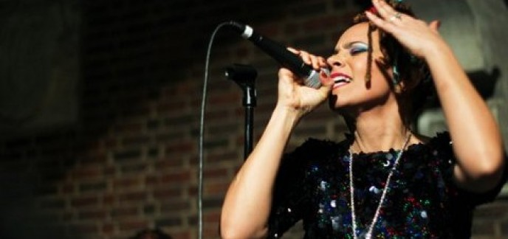
Featuring: Jessica Care Moore (USA), Kat Francois (UK), Yasus Afari (Jamaica), Ian Keteku (Canada), OpenSecret (Canada), Jamaal St. John (USA), hosted by Motion (Canada).

As a force that connects spoken word artists and audiences worldwide, the word brings into existence a creative possibility, a means to visualize the world as a better place.
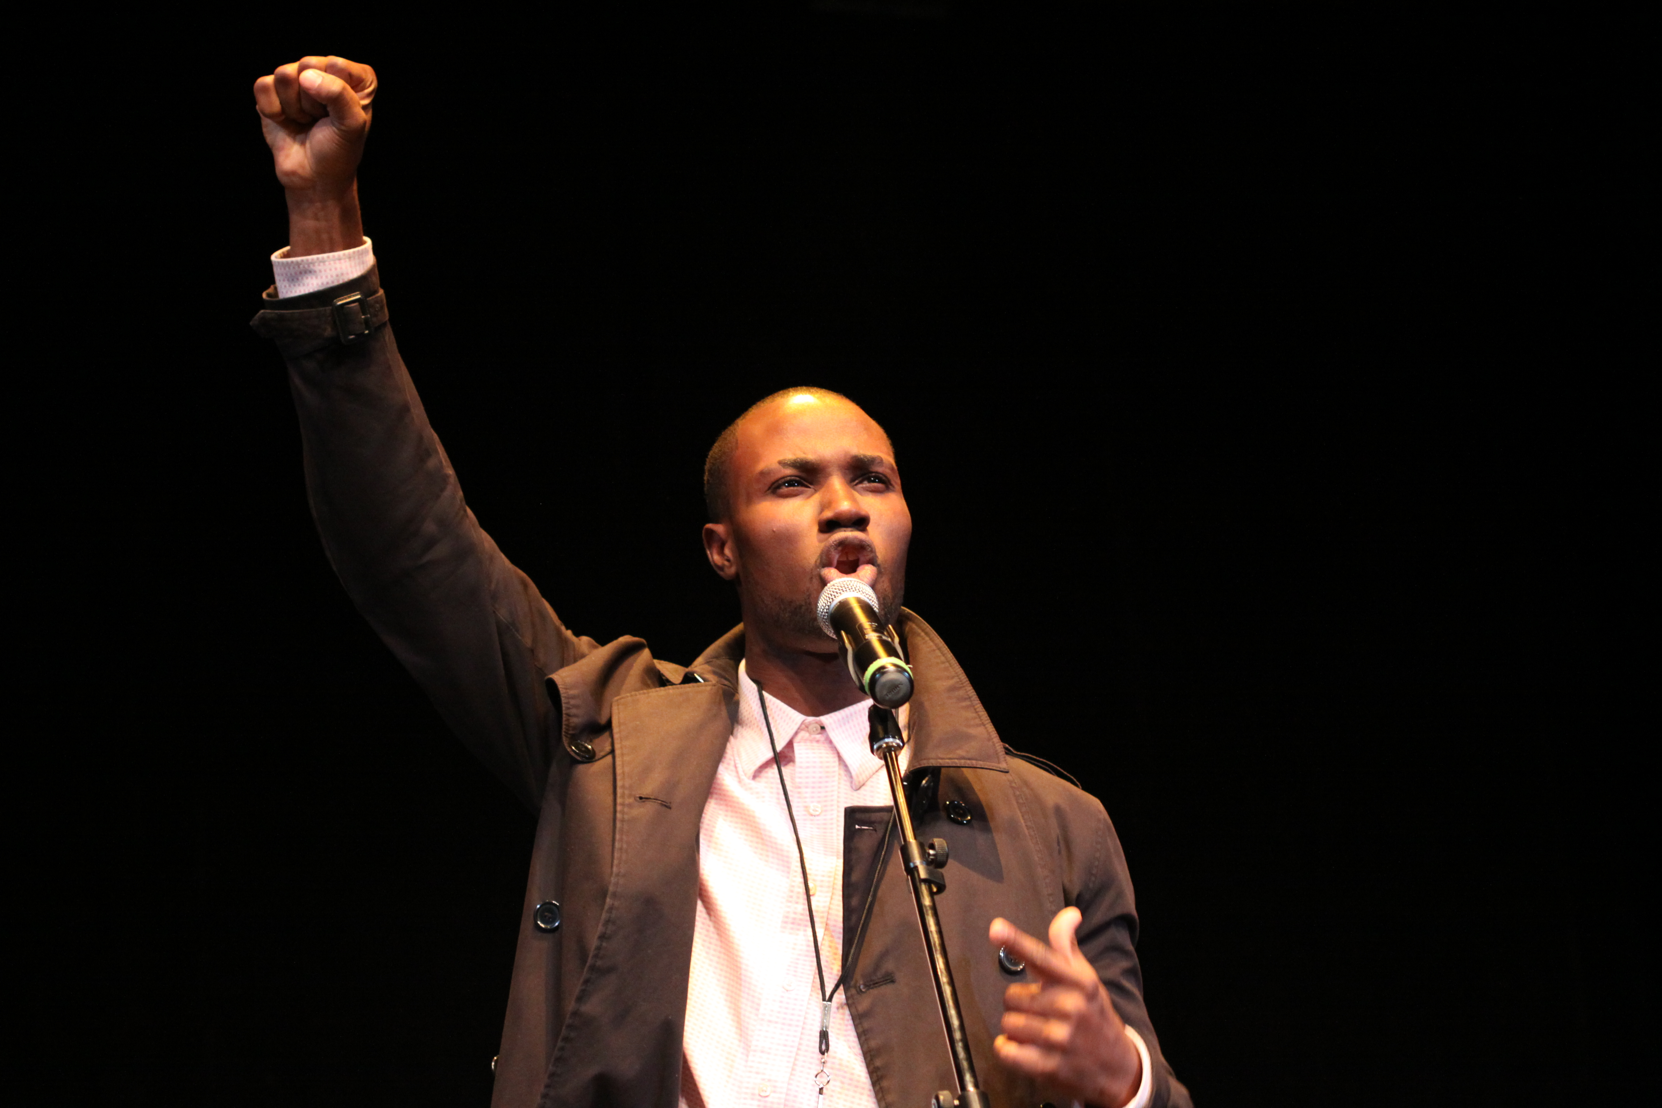

This stellar array of talent features the highest heights of new world griots that, through substance and style, have made their mark in re-shaping the world. Given the international caliber of the line-up, the night promises to be a powerful spoken word statement for the ages.
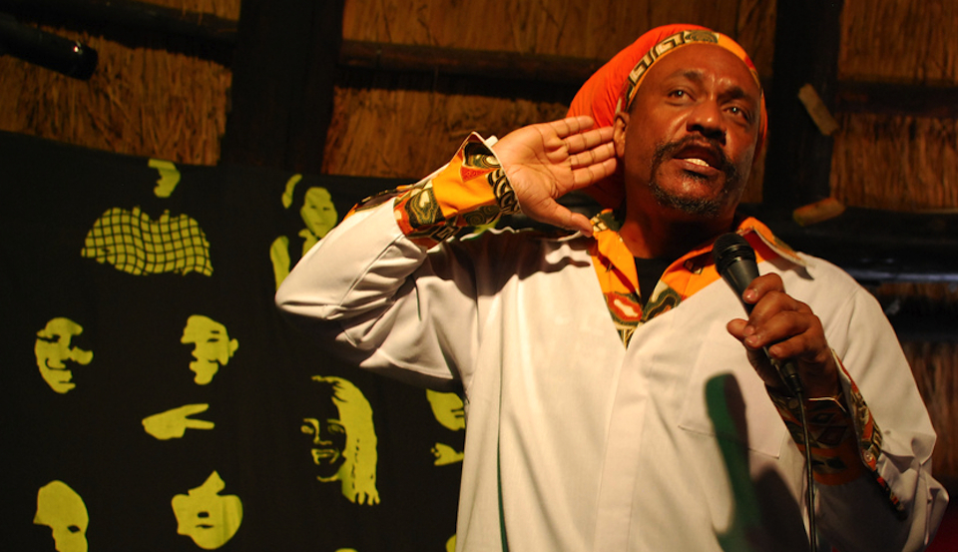

The show takes place at the Harbourfront
Centre’s storied performance venue, the Brigantine Room, located on the historic waterfront in downtown Toronto.

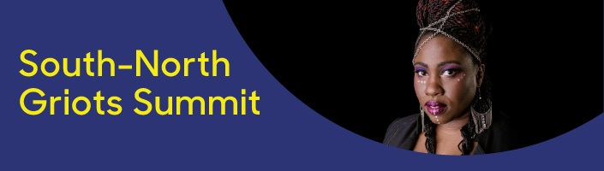
SUNDAY, MAY 31

The Griot Impact on Contemporary Diaspora
Sunday, May 31, 2015, Harbourfront Studio Theatre, 10:00 – 12:00 PM

Panelists/Presenters: Eddy Garnier, Adrian Green, Osei Alleyne, Talaam Acey, Anthony Bansfield

This presentation looks at the moral, political, social and spiritual function of the Griot, and the manifestation of that function in spoken word poetry in African Diaspora communities in the Americas and elsewhere. Music, theatre and other performance forms are central to the role of griots in engaging audiences. Traditionally, they are a combination of storyteller, singers, musician, poet, and historian. Through their spoken words, the griots are the living memories of humankind. This African tradition across seas, and south to north throughout the Americas, is a poetic voice that entertains and connects as a force of artistic communication, information, empowerment and transformation in our communities. Understanding what is constant and what has changed in this transition may be a way to better understand both where we have been and where we are going; for, as the griot reminds us, the world is old, but the future springs from the past.

Poetics Pan Americas
Sunday, May 31, Harbourfront Miss Lou’s Room, 10:00 – 12:00 PM

Panelists/Presenters: Andrea Thompson, Itah Sadu, Hyf the GypsySun, Klyde Broox, Rachael Collymore, Louise Profeit-LeBlanc

Some call it the Americas, and some know it as Turtle Island. It is sometimes referred to as the New World, but a callaloo stew of people have been moving through and living here for millennia, a crossroads where Ananse and Nanabozho swap longtime tales and tricks of the trade. With a nod to that meeting point, this session considers the style and substance of forms like Dub Poetry, Rapso, Hip Hop and other oral performance forms rooted in African styles with a mix of cultural influences that includes those of Indigenous artists voicing the experience and worldview of the First Peoples of this continent.

One Mic / Groundations Café
Sunday, May 31, Harbourfront Centre, Brigantine Room & Tent, 12:30 – 1:30 PM

All are invited to partake in the interactive spirit of spoken word by cheering or signing up for a spot on the open mic! All of the content will be family friendly. Inspired by the seminal International Dub Poets Festival in 1993, with a nod to the Panchayat format of our cousins in the Cascadoo Festival in Trinidad & Tobago, the Groundations are simply some space and time where peoples can relax, relate, reason, and informally build.

Telling Our Story/Closing Keynote
Sunday, May 31, Harbourfront Centre, Studio, 2:00 – 3:30 PM
Featuring: Presentation by the Northern Griots Network, and closing keynote address by Lillian Allen

Learn about the African-Canadian artists and presenters who were, and continue to be, key in the evolution of spoken word poetry.

The session will include consideration of archiving, media, information design, and communications, critical analysis, curatorial practice, and dissemination of information in expanding the understanding, growth, quality, and social impact of culturally diverse spoken word around the Globe.

The session closes with a special keynote speaker, none other than two-time Juno award winning artist and Creative Writing Professor at the Ontario College of Art & Design, Lillian Allen, to tell of our past, present, and next movements!
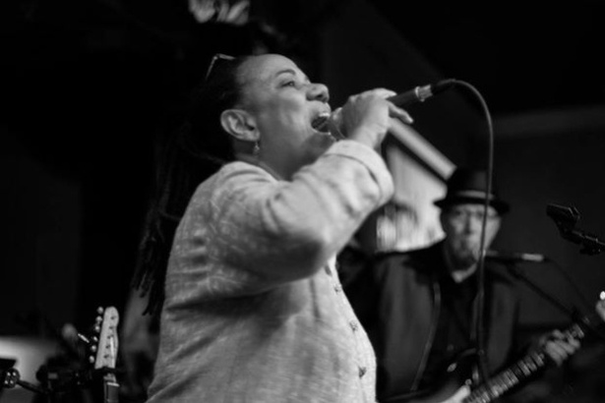
FREQUENTLY ASKED QUESTIONS

What does ‘South-North Griots’ mean?

- North tends to symbolize a way of orienting yourself, and has, in recent times, been associated geographically with Europe and North America, and also an associated with privilege and power. Conversely, the South has been associated with opposed meanings. Flows of migration have generally followed a pattern of southern hemisphere to northern hemisphere, largely for economic reasons, and this displacement has resulted in changes in cultures and traditions.
- On top of this more recent immigration pattern, for people of African heritage, the North Atlantic Slave Trade constituted an immense and traumatic dispersal of people to western and north western locations in the Americas, i.e. South America, Central America, the Caribbean, the United States, and Canada. The griot tradition was one of the most significant cultural elements that traveled with people of African heritage throughout this dispersal, as it is central to memory and sense of identity.
- A griot (gree’-oh) is a storyteller in traditional West African Culture who preserves the oral history of her/his village. Griots are revered orators who memorize important events in a village’s history including births, deaths, marriages and battles, and embody the collective memory of the village. A griot ensures that the community has the perspective of the past as well as the news of today upon which to base its decisions. A griot can speak and/or sing their stories, often to musical accompaniment, and entertain while drawing upon a history passed from generation to generation, from griot to griot.

We are the memories of mankind; by the spoken word, we bring to life the deeds and exploits of kings for the younger generations…. for the world is old, but the future springs from the past.
- Djeli Mamadou Kouyate in Sundiata: an Epic of Old Mali

- How did the griot tradition change in its westward and northern journey, and how does it continue to evolve? What distinguishes the practice of artists of African heritage, due to the influence of the griot tradition? What are its implications of this tradition for the continuing social and economic challenges faced by people of African descent in the Americas and elsewhere? What is the relationship of the griot tradition to the evolving artistic practice of spoken word? These are some of the key questions the Summit seeks to explore.
- The South-North Griots Summit stands for a distinct approach - 'inverted' to see from a south to north point of view, in concert with an Indigenous American perspective - in gathering some of the leading figures in our field to look at these questions, and combining dialogue, performance, and practical support for African Canadian spoken word artists/presenters.

Who is organizing the Summit?

- The Summit is organized by the Northern Griots Network (NGN), a collective of Canadian spoken word artists, founded in 2003, which functions as a network of culturally diverse spoken word poets and poetry presenters. One of our main priorities is to assist African Canadian spoken word poets in accessing resources and information that can help develop their skills and careers. For more information, see http://www.northerngriotsnetwork.com/about-us.html

- The NGN is partnering, in presenting the Summit, with Nia Centre for the Arts. Nia Centre is a multidisciplinary arts Charity that supports, showcases and promotes an appreciation of arts from across the African Diaspora. Nia Centre fundamentally believes in showcasing art for the purpose of human development, and that art is a powerful tool to encourage growth and progress. Nia Centre for the Arts is delighted to retrofit 524 Oakwood Avenue (south of Vaughan Road), to bring a fully accessible 200 seat performance facility into a designated arts community, the Oakwood Village. Nia Centre will create exhibition gallery space, a digital arts incubator and a multi-use space to house programs in Music, Literature, Dance, Photography, Film and Theatre. For more information, visit www.niacentre.org.

How did the South-North Griots Summit begin?

- In 2003, a group of African Canadian spoken word poets and presenters met in Ottawa to form the NGN as a strategic means of linking African Canadian poets and presenters through a two-day national-level meetings and dialogue, coupled with feature performances. They followed up by planning and delivering a series of tours, the NGN Xchange, with financial support for artists to visit and perform in different cities across Canada.
- In 2013, the Voices Of Canadian Artists cross Latitudes (VOCAL), a touring group of NGN artists/presenters, extended the reach of the NGN vision to an international level by supporting collaborative development of spoken word with Trinidad and Tobago artists and presenters.
- Through dialogue with T&T and Canadian artists/presenters, in the spirit of exchange and mutual development, the South-North Griots Summit was envisioned: a visit to Canada by Caribbean and Canadian artists/presenters, with Toronto and late May 2015 strategically chosen as the location and date due to the heightened interest in cultural activities associated with the Pan American Parapan Games.
- Copies of the concept were sent to NGN contributors for input, applications were submitted and partnerships formed throughout 2013-14 for in-kind and funding support to design and deliver the Summit, and planning sessions began in March 2014.

Who are the partners and supporters of the Summit?

- Funders and supporters of the Summit include the Ontario Arts Council, the Canada Council for the Arts, Ontario Ignite, Toronto2015, the Toronto Arts Council, the International Festival of Authors, and the Department of Canadian Heritage

- The Harbourfront Centre, a hub of artistic and cultural events located on Toronto’s lovely waterfront, and the Nia Centre for the Arts, a youth arts organization that fosters the development of African Canadian artists, are key partners in presenting the Summit.

- As well, the views and advice of NGN members from across Canada have been invaluable in providing a broad base of ideas and knowledge to enrich planning and delivery of the Summit. Key advice in the development of the Summit comes from an Advisory Committee that includes Kevan Cameron (aka Scruffmouth), Tanya Evanson, el Jones, Kym Dominique-Ferguson, and Ikenna Onyegbula (aka OpenSecret). Advisors and supporters also included Lillian Allen, George Elliott Clarke, Melissa Dean, John Akpata, Anne-Marie Woods (aka Amani), and our T&T fam (especially Mtima Solwazi and Rachael Collymore).

You who know what the past has been
You who work in the present tense
You who see through to the future
Come mek wi work together...
A mek wi talk
A mek wi analyse...
A mek wi stategise

- Lillian Allen, Revolutionary Tea Party

ORIGINS

Canada has a history of hosting literary gatherings of Black artists that have proved seminal in their artistic and social impact. The famous 1968 Black Writers Conference in Montreal brought together such noted writers and political thinkers as Walter Rodney and Stokely Carmichael. The Conference itself was a culmination of a series of writer lectures organized by the Conference Committee on West Indian Affairs (led by the noted St. Vincent historian, Alfie Roberts), which helped shape the future of Black people in Canada and across the Pan-African Diaspora, and featured such influential writers as George Lamming, C. L. R. James, and Orlando Patterson.

Most recently, a critical event carried on and evolved the intent of the 1968 conference. Spearheaded by Lillian Allen and a collective of Toronto-based dub poets, the 1993 International Dub Poetry Festival, was a ground-breaking gathering of dub poets with panel discussions and performances featuring the likes of Mutabaruka, Sister Jean Breeze, and Oku Onuora from Jamaica, Brother Resistance and Brother Books from Trinidad, Winston Farrell from Barbados, Ras Mo from Dominica, Martin Glynn from Britain, and Mzwakhe Mbuli from South Africa.

The Festival inspired an emerging generation of spoken word poets, including a group of young poets from Montreal called DAP (the Diasporic African Poets) who were invited to perform and whose members included myself, the nth digri. My most poignant memories of that festival are of the electrifying Concert Hall performances, as well as the creative tension of the dynamic exchanges and welcoming/mentoring vibes of the Groundations sessions.

Nine years later, Toronto again hosted the 2004 International Dub Poetry Festival, organized once more by the Dub Poets Collective. The scope was again international, with poets such as Britain's Martin Glynn, Miami-based poets Malachi Smith, and Jamaica's Cherry Natural. The festival also featured a number of Black Canadian spoken word poets – such as Dwayne Morgan, Motion, nth digri, nah-ee-lah – who extend dub poetry by fusing it with other genres (e.g. hip hop, rapso, and American slam poetry styles).

Workshops included a 'Master Class: Dubbing with Lillian Allen & Clifton Joseph,' a panel discussion in 'Re-reading Dub Poetry: Its Poetics, Politics & Culture' co-sponsored by the Ryerson Caribbean Research Centre, and a panel on 'Dub Activism' co-sponsored by the Centre for Human Rights and Equity. The festival also featured a Performance in 'Groundings & Soundings Open Mic' as a 'main source of initiation, experimentation and development for emerging practitioners'

The Northern Griots Network (NGN) gathering in Ottawa in July 2003 was a strategic meeting, accompanied by a momentous performance, of a next generation of Black Canadian spoken word artists, particularly in terms of the resulting NGN Xchange series that saw poets from cities across Canada - including Vancouver, Toronto, Halifax, Toronto, Montreal and Ottawa - travel to perform to new audiences.

The fact that the NGN core membership were not only strong spoken word artists but skilled organizers and promoters helped drive the inception of the Canadian Festival of Spoken Word (CFSW) in 2004. NGN founders who produced series such as the Golden Star Lounge (Ottawa), Up from the Roots (Toronto), and Word Iz Bond (Halifax) played leading roles in hosting the first several iterations of the Festival (2004, 2006, and 2007, respectively). The CFSW was built largely from the linkages forged through the NGN Exchange. Other initiatives that would follow years later, such as the development of the recent anthology of African Canadian Poetry, The Great Black North, were rooted in the NGN Exchange, as acknowledged by co-editor Kevan Anthony Cameron.

In August 2013, a group of five Black Canadian spoken word poets collectively titled Voices of Canadian Artists across Latitudes (VOCAL), traveled to Trinidad and Tobago to take part in the Cascadoo festival of Caribbean spoken word in Port-of-Spain. The group performed, delivered showcases, and networked with Caribbean poets in sharing the expertise developed in Canada as organizers and artists; reached new audiences with work that shared certain similarities of style and language, given the Caribbean origins of group members; and learned from the unique talents and forms arising in Trinidadian spoken word community (for instance, participating in a steel pan and poetry fusion performance).

It was significant that that the tour took place during the 15th anniversary of the record WordLife: Tales of the Underground Griots, a collection of Canadian spoken word and music that documented the coming of age of the post/neo dub wave of standard-bearers for Canadian spoken word poetry. The five artists were WordLife contributors who had continued to not only grow their artistic careers but also foster the development of a next cadre of spoken word artists.

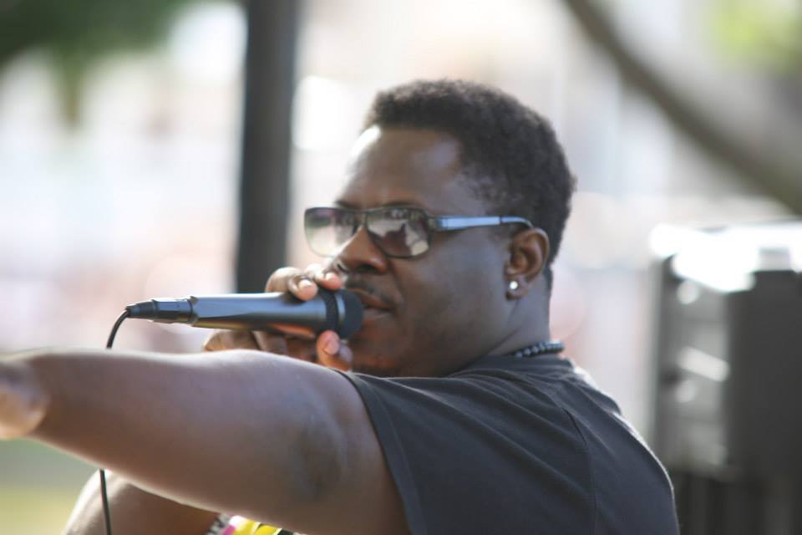
In their discussions with their Caribbean counterparts, the VOCAL team - Dwayne Morgan, Motion, nth digri, Eddy DaOriginalOne and Manchilde - forged a commitment to see Trinidadian artists travel to perform in Canada, in the same spirit of xchange that had proven so key in the delivery of the NGN vision. In the fertile Caribbean soil was planted the seed for the South North Griots Summit.

BIOGRAPHIES

Adrian Green (Barbados)
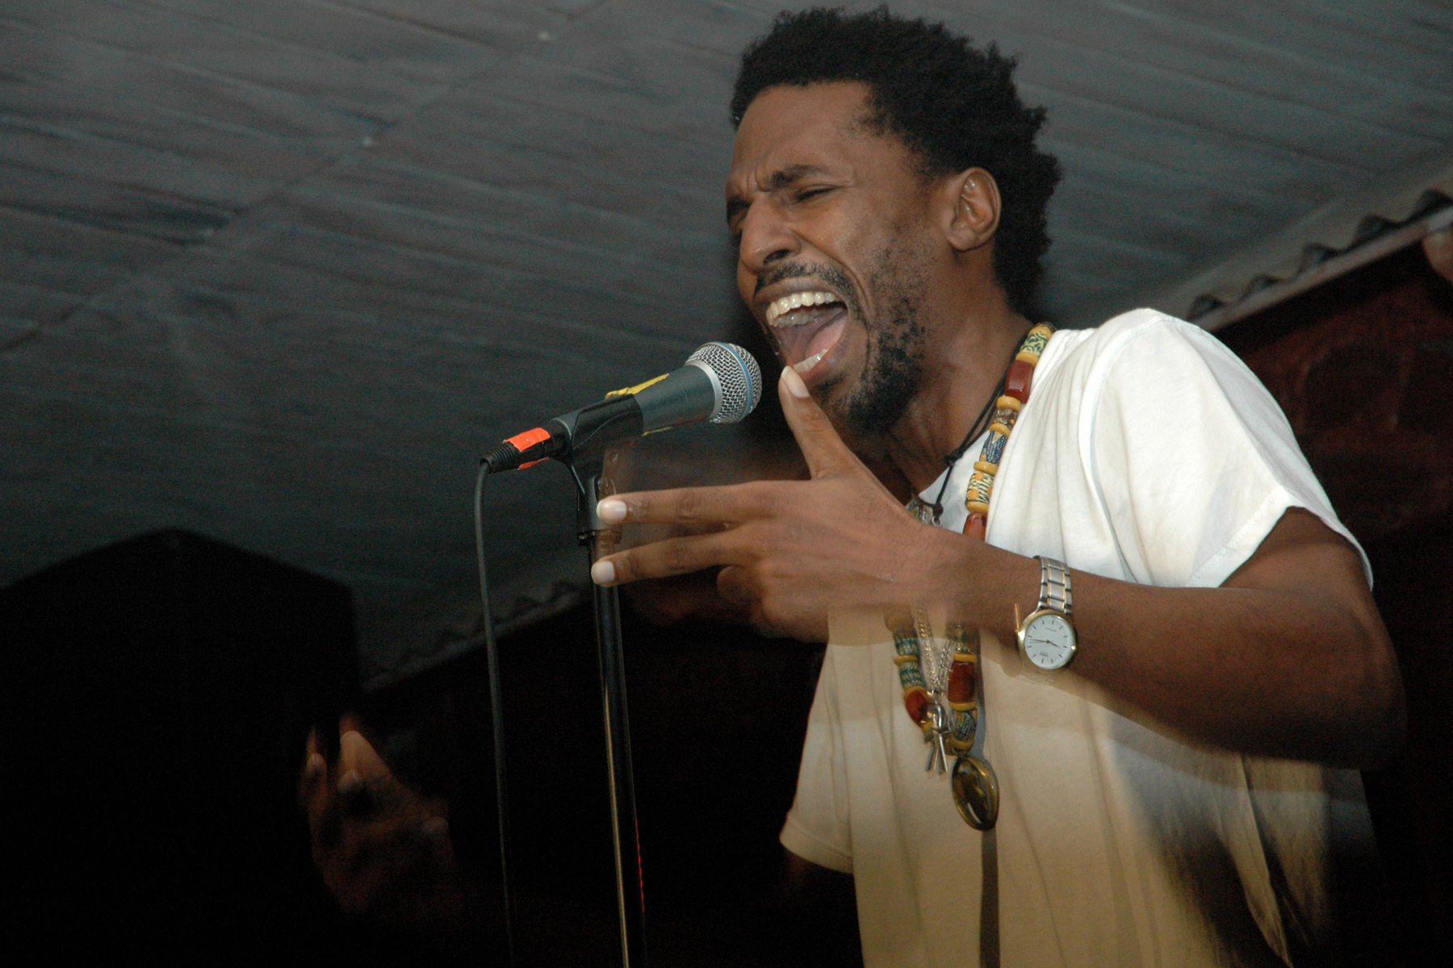
Adrian Green is a Barbadian performance poet engaged in writing about Bajan society and the African diaspora.

Adrian was first introduced to performance poetry as a student in the US and took the art form back to Barbados where he would become a three-time winner of the Barbadian Slam Poetry championships and a Gold Award winner in Barbados' National Festival of Creative Arts.

He has performed widely throughout the Caribbean, the US and Ghana. His two albums of poetry are “Random Acts of Conscience” and “Hard Ears”.

http://www.artsetcbarbados.com/aestudios/adrian-green

Ahmed Knowmadic (Edmonton, Canada)
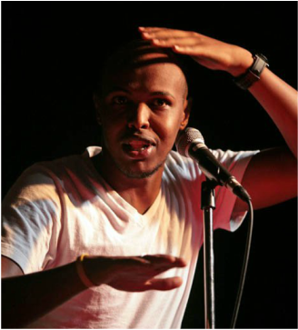
Ahmed Ali also known as Knowmadic is a Somali-Canadian poet who is known to use humor and word play in his poetry to create awareness of social issues that aren’t often given attention.

Ahmed feels he is continuing the legacy passed on by his ancestors who shared a common interest in spoken word. In the few years that he has been active, Ahmed has been able to achieve national recognition for his witty, humorous and metaphorical style of poetry.

http://www.ahmedknowmadic.com/

Amani (Toronto, Canada)

Amani “Contemporary Blues Poet” is the 2013 recipient of the BBPA Harry Jerome Award for Excellence in Entertainment is. She is an actor, playwright, producer, arts educator, director and creative consultant. Amani has performed in When Sisters Speak, Irie Fest, and Hillside Music Festival. She featured at The Africa Festival of Art and Culture in Nova Scotia, the Nuyorican Café in New York City, the Drum in Birmingham, England, The Word Power International Literary Festival in London, England and Rapso fest in Trinidad. Her second CD is “Poetree Huggin.” She is currently the Creative Director/Production Coordinator for a new Musical called “The Journey” The Living History of Regent Park. Her new play She Said/He Said fuses poetry, monologues, and song and has its World Premiere in 2016 at Black Theatre Workshop in Montreal.

www.imaniartsbiz.com

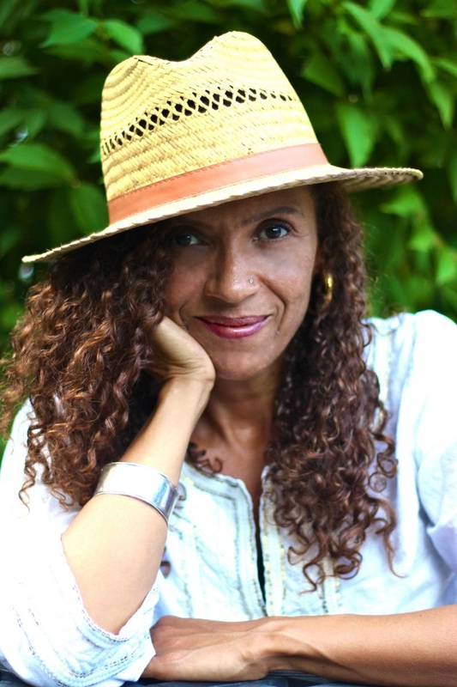
Andrea Thompson (Toronto, Canada)

Andrea Thompson is a writer, teacher, activist and mentor, and a force on the Canadian spoken word scene for the past twenty years. Her collection, Eating the Seed, was featured on the reading list at the University of Toronto, and at the Ontario College of Art and Design (OCAD). She is the co-editor of Other Tongues: Mixed-Race Women Speak Out, an anthology released by Inanna Publications in 2010. Her debut novel, Over Our Heads, was published by Inanna Publications in 2014.

Her poetry was featured in the film Slam Nation, on Bravo TV's Planet Poetry, TVO’s Imprint, and on a variety of CBC radio programs. In 2009 she was awarded the Canadian Festival of Spoken Word's Poet of Honour for Outstanding Achievement, and in 2005 her CD One was nominated for a Canadian Urban Music Award. Her essay on the history of Spoken Word in Canada was published by Edition Maelstrom as the prologue to Le Making of d’un Homme by Dwayne Morgan. She teaches Spoken Word and Poetry at OCAD, and is a member of the WordSpell collective.

http://www.andreathompson.ca/
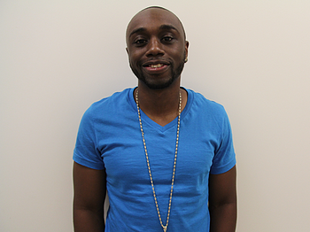
Andrew “Jaydahmann” Cox (Toronto, Canada)

The Program Coordinator at Nia centre for the Arts, Andrew Cox, is also the artist many call Jaydahmann. As a man who understands the power of music, the power of his voice, his music mirrors life through his eyes, life he has seen as an impoverished child, alienated teenager and now as a trailblazing advocate for marginalized communities.

Jaydahmann’s hit single, “Anything”, dominated Toronto’s FLOW 93.5 OTA Live #1 spot for 4 weeks in a row. He is a graduate of Nia Centre’s “Art of Facilitation” program and currently the facilitator of AFRO (Artists For Re-creating Opportunities), Nia Centre’s youth steering committee.

http://www.jaydahmann.com

Anthony Bansfield (Ottawa, Canada)

Anthony Bansfield, aka the nth digri, is inspired by his Caribbean and Canadian heritage, hip-hop culture, and the African griot tradition. He produced WordLife, a poetry and music compilation of top African Canadian spoken word artists. His record, Tales of the North Coast, was nominated for a Canadian Urban Music Award and a Harry Jerome Award.

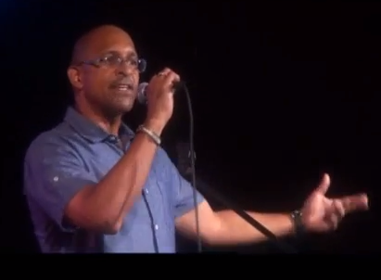
Anthony produced the Ottawa spoken word series, Golden Star Lounge, and led a team to Chicago for the National Poetry Slam, where his poem Sugar Cane was selected for Best of the 2004 NPS anthology. He co-founded the Canadian Festival of Spoken Word, the first national slam tournament in Canada, and was recognized the Festival’s Male Poet of Honour in 2010. He was also recently elected to the VerseFest Ottawa Poetry Hall of Fame.

One of the founders of the African Canadian spoken word artists collective, the Northern Griots Network, Anthony has performed in Canada, the USA, and Caribbean, most recently at the Cascadoo Festival in Trinidad and Tobago. His recent record, south is north, is available on bandcamp.com.

https://nthdigri.wordpress.com/
Britta B (Toronto, Canada)
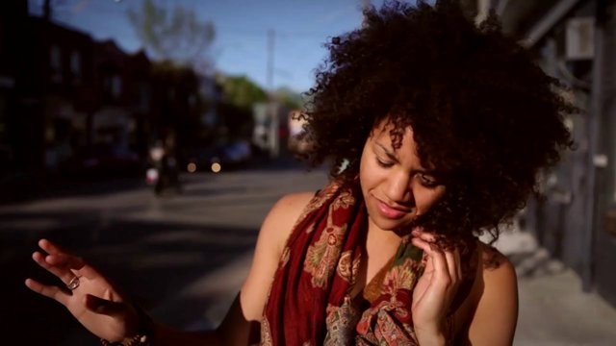
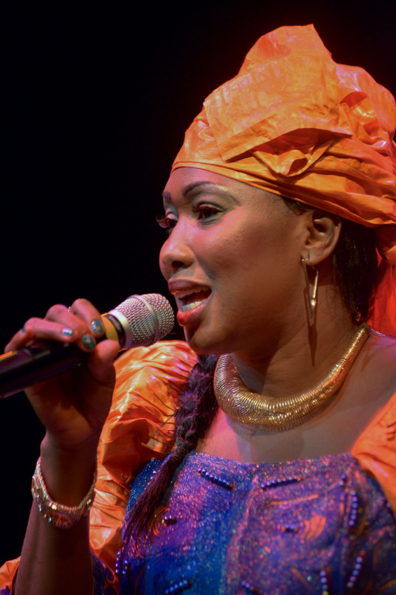
Britta “Britta B” Badour has embodied “living the dream” as a spoken word artist, keynote speaker and artist educator. Born and raised in Kingston, Ontario, she now resides in Toronto, acting as an ambassador for R.I.S.E. Edutainment and artist educator for UNITY Charity. Britta has traveled across North America as a keynote speaker and
spoken word poet, and inspiring audiences through her own personal performances and representing various organizations and causes. Britta has spoken at two TEDx conferences, and as co-host of the What Makes A Man (White Ribbon) Conference, she and her team redefine the meaning of masculinity and the importance of raising awareness in regards to violence against women.

https://missbrittab.wordpress.com/about/

Cheka Katenen (Toronto, Canada)

A Djeli (“jelee”) in the Manding tradition and known also as a Griot (“gree-o”), is a West African poet, praise singer, travelling musician, and repository of oral tradition and history. Cheka Katenen Dioubate is a Griot, descendant from a line of famous Djelis from Guinea, and raised in the ancient city of Kankan, Guinea. The title track of her debut album Djeliou, produced by Quammie Williams, is a tribute to all Djelis, to her mother and father and the rich tradition they have passed down.

In 2009, Cheka shared a stage with the world-renowned kora player Ballake Sissoko where she demonstrated and explained the history of the Manding Djeli. She also presented workshops through dance and music presentations at schools in Toronto. In 2006, Cheka organized TAMALA (Toronto African Music And Living Art), and in 2010, at the Luminato Festival, shared the stage with Salifou Keita before an audience of 7,000. In 2011, Cheka toured Guinea to promote her album, “Dielilou”. In 2014, she performed at the Griot Night concert at Daniels Spectrum, and Nuit du Basin Festival. Her second album, “Bimogo” launched in May 2015.

http://www.chekakatenen.com
Curious Ringo (Trinidad and Tobago)
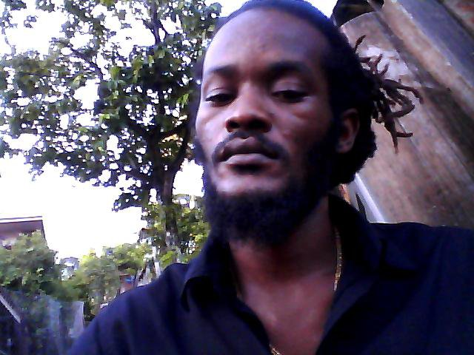
Curious Ringo was born R. Ryan Samora in Carenage, Trinidad. While growing up he was inspired by his neighbourhood and lyrical battles; he came to be known first as Ringo in high school and later as Curious. He later changed his name to become Curious, around the same time became baptized in the Ethiopian Orthodox Church. Today Curious Ringo performs highly appreciated, locally relevant material in the spoken word forms of Trinidad and Tobago and the Caribbean. He has performed his rapso poetry at series such as Second Stage and ONE MIC, as well as at Carnival calypso ‘tents’ across Trinidad. His most recent single/video for Carnival 2015 is “In De Building.”

https://www.facebook.com/pages/Curious-Ringo/38915559430

Dasha Kelly (Milwaukee, USA)
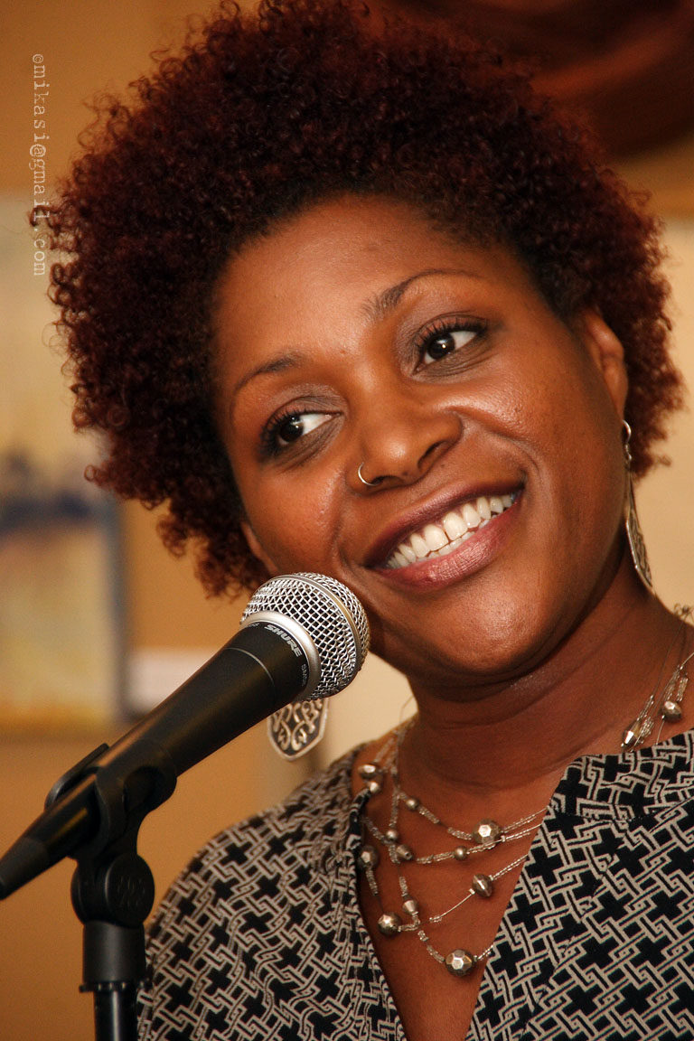
Dasha Kelly is founder and director of Still Waters Collective, an arts initiative providing creative writing programs to schools, prisons, boardrooms and community centers.

Dasha has performed at colleges and events across the U.S., to include HBO's Def Poetry Jam, Opium Magazine's Literary Death Match, and opening for Grammy-nominated Angie Stone.

Locally, she encourages youth throughout Milwaukee to write and tell their stories. In 2010 and in 2008, Dasha was listed by OnMilwaukee.com as one of the "Top 100 Coolest Milwaukeeans" and, this year, named to a writer-in-residence post as the newest Pfister Narrator.

http://dashakelly.com

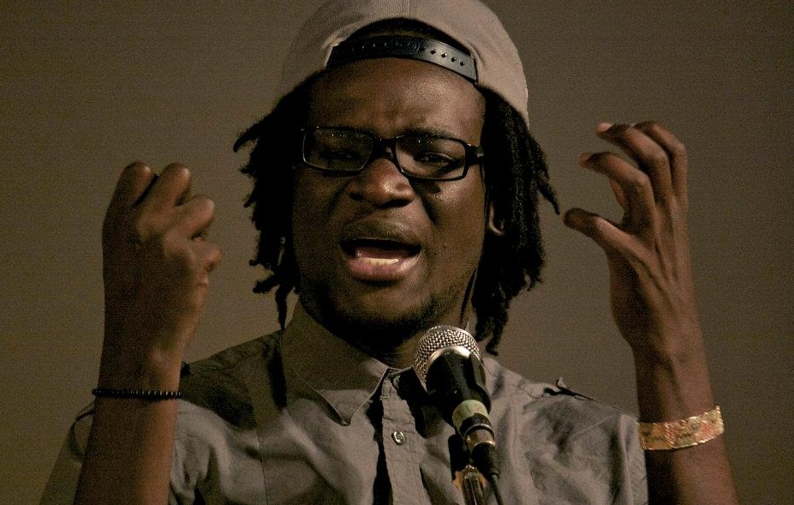
David Delisca (Toronto, Canada)

Born in Haiti, raised in West Palm Beach, Florida, David Delisca is a spoken word artist/poet, actor and comedian. He is a four-time member of the Toronto Poetry Project’s national poetry slam team. He has travelled and performed across the country to share his words at many literary festivals and venues. His work has been published in various anthologies and magazines such “The Great Black North” (Frontenac Press), “Basodee” (General Store Publishing House). David recently published his first collection of poetry entitled “I Grew Up Right Beside You” in February 2012.

David has the experience with sharing his craft to encourage and inspire people through facilitation and programming with organizations such as Young People Theatre, Manifesto Community Projects, Unity Project, and Literature For Life.

http://delisca.com/

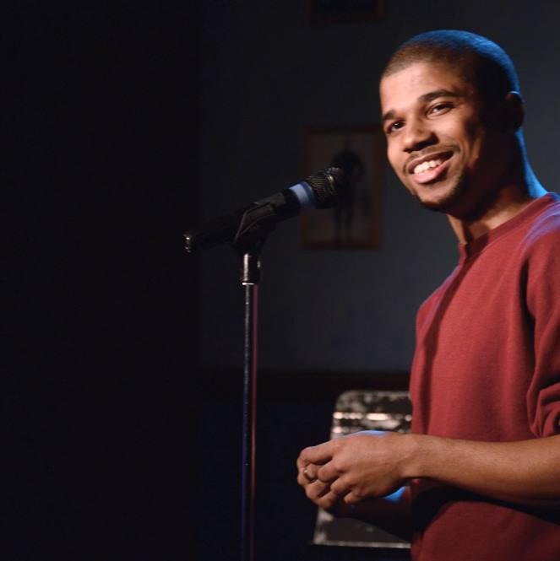
Deonte Osayande (Detroit, USA)

Deonte Osayande is a writer from Detroit, Mi. His poems and essays have been published in over a dozen publications and have won awards in the Dudley Randall Poetry Contest, the Wayne Literary Review Poetry Contest and have been nominated for a Pushcart Prize.

Deonte is a three-time member of the Detroit National Poetry Slam Team and slammaster of the Freshwater Wordsmiths Poetry Slam, and a poetry reader for The Adroit Journal.

He also teaches creative writing through the Inside Out Detroit program, and is a Professor of English at Wayne County Community College.

http://deonteosayande.blogspot.ca/

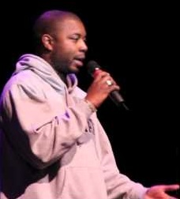
Dwayne Morgan (Toronto, Canada)

Dwayne Morgan began his spoken word poetry career while still in high school, founding Up From The Roots entertainment to promote the positive artistic contributions of African Canadian and urban artists. He has received both the African Canadian Achievement Award, and the Harry Jerome Award for Excellence in the Arts, and is the winner of 3 Canadian Urban Music Awards (2001, 2003, 2005). In 1998, Morgan introduced regular poetry slams to Toronto, and in 2005 he was recognized as Poet of Honour at the Canadian Festival of Spoken Word in Vancouver.

Dwayne has published 6 books, including The Man Behind The Mic (2002) and Long Overdue (1999), as well as several chapbooks, such as The Revolution Starts Within (1996), and Straight From The Roots (1995). In 2009, Morgan's work was translated into French in the book, Le Making d'un Homme. H has also recorded a number of albums, including The Evolution (2001), Soul Searching (2003), Idle Hands (2011), and a commemorative DVD entitled, Dwayne Morgan: the First Fifteen.

Dwayne has performed for the former Governor General of Canada, The Honourable Michaelle Jean, and has shared the stage with many of Canada's top artists including Russell Peters, Deborah Cox, Kardinal Offishal, Jully Black, and recording with Canadian artists including Grammy nominee, Drake.

To further explore his creativity, Dwayne collaborated with Driftwood Studios to film,” Three Knocks,” a ten-minute film based on his domestic violence poem of the same name, which premiered in Toronto's Reel World Film Festival. In March 2008, Dwayne hosted his first photography exhibit, The Sum of Her Parts, exploring female body image.

Dwayne has toured across Canada, the United States, Jamaica, Barbados, England, Scotland, Belgium, Budapest, Germany, France, Norway, and Holland. His emphasis on quality has driven his success, and has made him a well-respected component of Toronto's urban music community, as well as the North American, and Global, spoken word scenes.

http://dwaynemorgan.ca/

Eddy DaOriginalOne (Toronto, Canada)

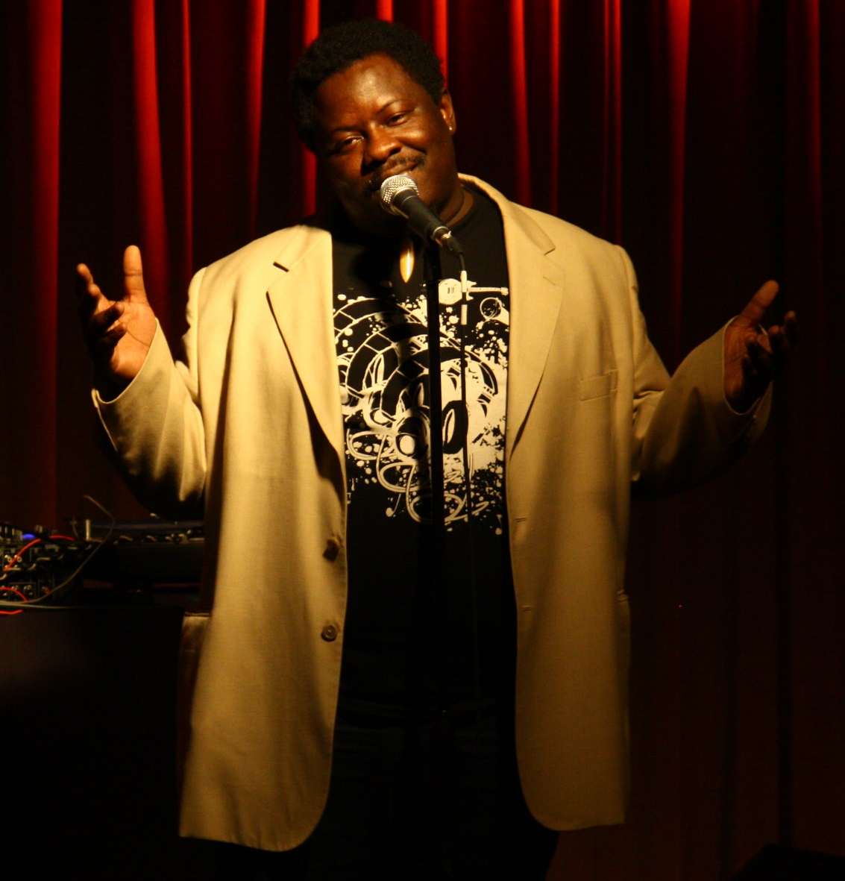
Eddy is a beat-box poet, art educator, event/entertainment Coordinator, recognized across Canada for his spoken word poetry, performing and producing a variety of shows and events, and contributing in the studio on a number spoken word recordings as engineer, arranger and producer. An exceptional performer, he entertains audiences through his engaging style, unique talent as a beat-boxer, and charismatic stage presence.

Born in Canada and raised in Trinidad and Tobago, Eddy proudly represents his dual heritage, and has performed across North America, including Vancouver, Calgary, Halifax, Montreal, Ottawa, Toronto, New York, and Miami. He owes his Spoken word beginnings to his mentor Oji Adisa of MACPRI International, who first put this Ottawa native on a spoken Stage in Toronto in I991presentation titled "Young Poets of the Revolution". he then went on to be artistic director of the Ottawa Chapter Young Poets Ottawa.

He has featured at numerous literary and music events, including the famed “When Brothers Speak” Spoken Word Concert in Toronto, the Canadian Festival of Spoken Word, the art/music/poetry series Soul Deep in Montreal, and the ‘2011 Canadian Beat-boxer Championship’ (as a VIP judge).

Eddy’s work is published in various African Canadian contemporary poetry anthologies, including the WordLife record, and the T-Dot Griots and Great Black North print anthologies. His full-length recordings include Stories, If Yuh Heard Spread the Word, Caribbean Tales, and Renaissance Man. Eddy has appeared in the two spoken word documentary films: In the Making, (2010), and Speak (2008). He also has produced a number of spoken word performance series, the Annual Poetry through Black eyes series, then Poetic Soul Spot in Ottawa, Soul Deep in Montreal and created and performed musical/spoken word productions of his work, such as Beats, Rhymes and Lights in Toronto. In addition, he has conducted Beatbox Workshops for the Toronto Public library also writing and performing spoken word workshops as a guest lecturer/facilitator at the Literacy for Hip Hop program (Toronto), Urban Arts (Toronto), Word is Bond (Halifax), Harambee Centre (Ottawa), Dartmouth High School (Nova Scotia) and Cascadoo Spoken Word Festival (Trinidad and Tobago).

www.Eddydaoriginalone.com

Eddy Garnier (Gatineau, Canada)

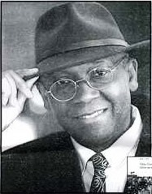
Eddy est né à Hinche en Haïti, il est devenu, par la force de l'impromptu Poète romancier, nouvelliste, auteur de contes de monologues et autres. Après ses études secondaires au Canado haitien il arrive à Montréal 1972. Actuellement, il vit encore dans l'Outaouais québécois depuis 1975.

Il a poursuivi ses études à l'Université de Montréal, à l'Université du Québec en plus de sa formation reçue au Conservatoire national d'art dramatique de Port-au-Prince. Il détient un Bac en administration des affaires et une maîtrise en Management des services Publics Régionaux.

En 1994, il est invité à Besançon, (France) pour participer au Salon du livre en Franche Compté. En mars 1995, il est choisi comme invité d'honneur au salon du livre de l'Outaouais québécois dont le président du Salon, cette année là fut Gilles Vigneault . En 1995, il se retrouve écrivain invité au Salon du livre de Toronto. Invité à deux nombreux soupers littéraires par les associations des auteurs des Outaouais.

http://pages.videotron.com/eddyg/

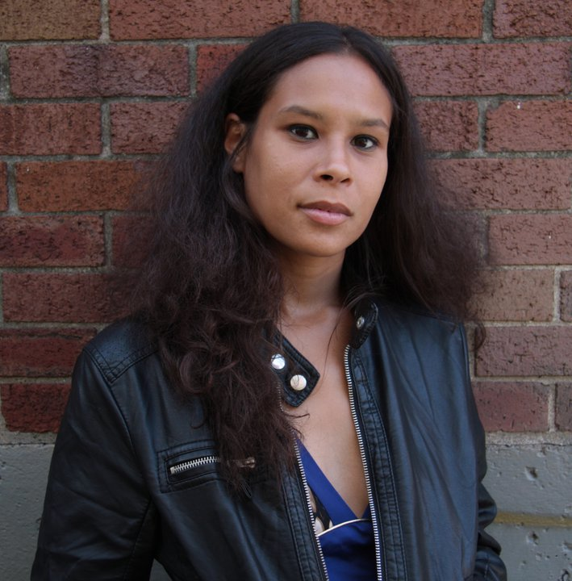
El Jones (Halifax, Canada)

El Jones is a spoken word activist and teacher who has performed all over Canada. In 2012, she was sponsored by Citizenship and Heritage Canada on a reading tour of Nova Scotia with George Elliott Clarke.

She was the captain of the two-time National Champion HaliFAX slam team and has performed across Canada as a feature performer. Her poetry is particularly committed to political causes and social justice and El has worked extensively with organizations around Halifax performing and presenting on issues of social change.

El is currently the artistic director of Word Iz Bond Spoken Word Artist Collective and can be seen performing on the third Thursday of every month at the Company House at 2202 Gottingen Street in Word Iz Bond's SPEAK! Series. She currently teaches in the African Canadian Transition Program at NSCC and in the Women's Studies program at Acadia. El Jones will serve as HRM's Poet Laureate for two years 2013-2015.

http://www.halifax.ca/culture/PublicArt/PoetLaureate.php

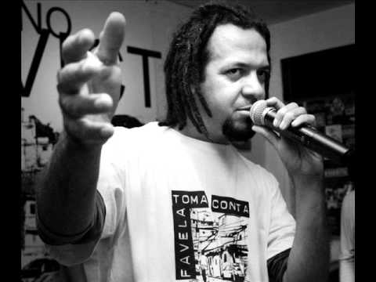
Emerson Alcalde (Sao Paulo, Brazil)

EMERSON ALCALDE is from São Paulo, Brazil. He works as a coordinator of cultural projects in education. As well as being an art educator, he is an actor, Slam Master of the GUILHERMINA SLAM, and Event Curator the Sofala Slam Poetry series. He authored a book of poetry, (A MASS, 2011). Representing his nation, Emerson reached the finals in France at the 2014 World Grand Slam of Poetry, and narrowly finished second in a tie-breaker. Emerson won his spot as Brazil's National slam champion by winning the "Slam do Grito", and "Slam 13" series. He was also featured on the Kamau CD "Entre" in 2012.

http://emersonalcalde.blogspot.ca/

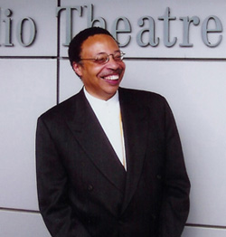
George Elliott Clarke (Toronto, Canada)

George is a poet, playwright and literary critic, and E.J. Pratt Professor of Canadian Literature at the University of Toronto. He taught English and Canadian Studies at Duke University, and is currently a visiting professor of Literature at Harvard University. He was born in Nova Scotia, a seventh-generation Canadian of African-American and Mi’kmaq Amerindian heritage. He earned a B.A. honours in English from the University of Waterloo, an M.A. in English from Dalhousie University and a Ph.D. in English from Queen’s University. Before joining academia, he was also a newspaper editor in Halifax, and still writes a column for the Halifax Herald and other publications.

As a writer George Elliott Clarke has published in a variety of genres: Saltwater Spirituals and Deeper Blues (1983), Blue Exile (1994), a verse-novel, and two verse plays, Whylah Falls: The Play and Beatrice Chancy. He also wrote the novel, George and Rue, as well as a screenplay for the feature film, One Heart Broken Into Song (Dir. Clement Virgo, 1999). Clarke continues to publish poetry with Provençal Songs (1993 & 1997), Blue (2001) and Illuminated Verse (2005). His Execution Poems (2001) won the Governor General’s Award for Poetry. Clarke has been instrumental in promoting the work of writers of African descent, especially those of Nova Scotia. In 2002 he published, Odysseys Home: Mapping African-Canadian Literature.

http://canadian-writers.athabascau.ca/english/writers/geclarke/geclarke.php

Ian Keteku (Toronto, Canada)

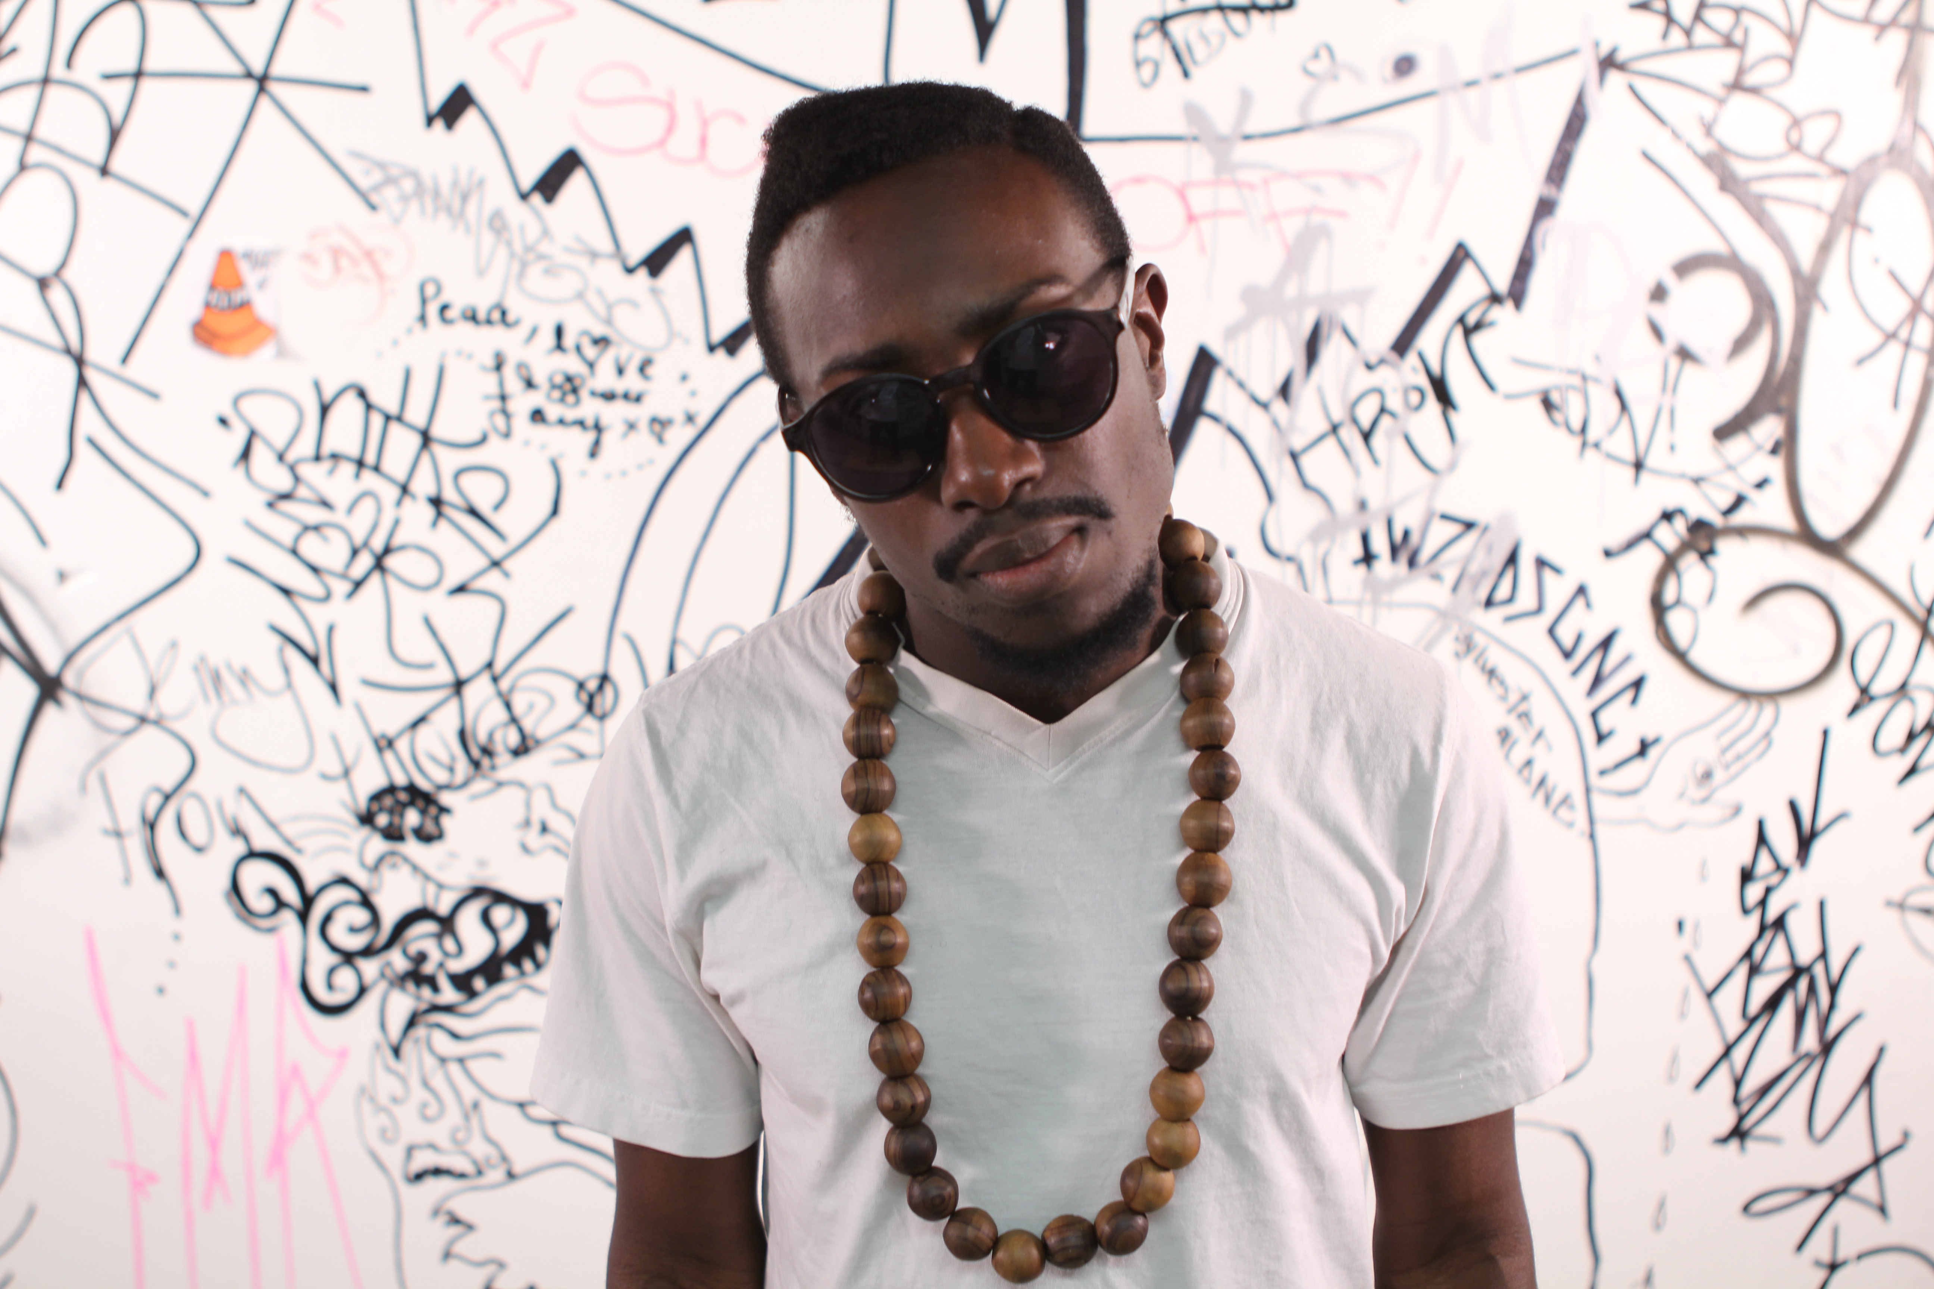
Ian Keteku is a poet, musician and freelance journalist. Raised in Canada and of Ghanaian heritage, Keteku earned the title of World Slam Poetry champion in France in the summer of 2010. He is also a two-time national slam champion, and has showcased his poetry and art all over the world. He has produced thought-provoking poetic films, and conducts poetry, writing and performance workshops for students.

In 2011, he released his first spoken word album L.F.P.E. Lessons From Planet Earth (Re-Evolution), drawing influences from Afro-beat, trip-hop, hip-hop, folk music and blending them with socially conscious lyrics. In 2015, Ian released Love and Lumumba, his sophomore spoken-word album. He has been featured in the Calgary Herald, Fast Forward Magazine, and Edmonton Journal, CBC television, CBC radio, Radio Canada, and a number of campus radio stations. As a freelancer, Keteku has written for the Ottawa Citizen, Calgary Herald, Toronto Star, Globe and Mail, and others. Through video journalism Keteku has produced stories for CBC Calgary, CJTV News and i-Channel, where he covered the victory of Barack Obama in Chicago.

http://www.ianketeku.com/

Itah Sadu (Toronto, Canada)

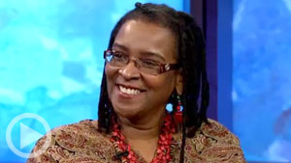
Itah Sadu is a storyteller, writer, entrepreneur and community builder. As owner and operator of the bookstore, Different Booklist, she has established a cornerstone for writers and cultural workers in Toronto's culturally diverse communities, particularly in terms of African Canadian and Caribbean literature. She is a board member of Caribbean Canadian Literary Expo, with a purpose to encourage young emergent writers and illustrators and youth interested in self-publishing and e-book applicants.

A strong advocate for social justice, she planned and implemented programs for youth from Aboriginal and racialized communities residing in high density neighbourhoods. One such program is the Fresh Elements/Fresh Arts program – an initiative designed for youth to develop technical and production skills in the cultural industries. As well, she is founder of the Walk with Excellence for schools in Toronto west and founding member of the annual Underground Freedom Ride in celebration of Emancipation Day.

Itah is also a bestselling children’s author, whose books - among them, the popular 'Christopher' stories - have been adopted by schools for curriculum, and adapted to film. She is also founding member of the MY People Literary Awards of the Black Book Affair.

In her work with the Toronto Arts Council, Ontario Arts Council and Scarborough Arts Council, she advocated for criteria for diverse artists. She has collaborated with school boards, colleges and universities across the province of Ontario and Canada in providing opportunities for students, youth and educators from diverse communities.

Holding a Bachelor of Arts Degree in Political Science from York University, Itah has received numerous awards and certifications, including those from the Black Business and Professional Association, the Toronto Arts Council Foundation, and the African Canadian Achievement Award for Excellence in Business. She is also a Harry Jerome Scholarship Trustee and board member with a purpose to build awareness of scholarships and grant opportunities for youth.

http://www.adifferentbooklist.com/

Jamaal St. John (New Jersey, USA)

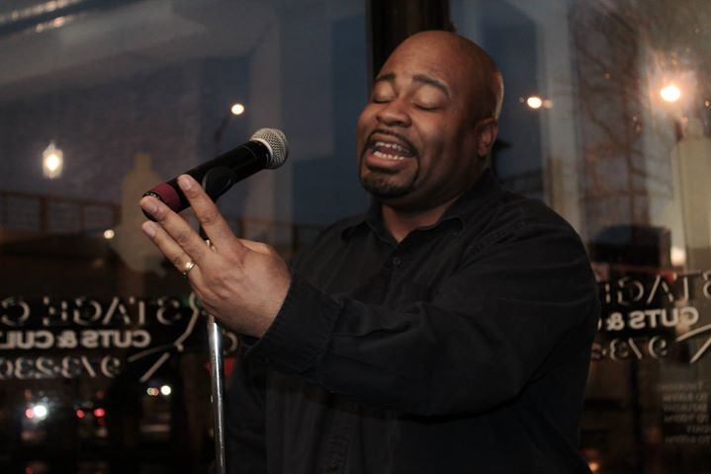
Hailing from New Rochelle, New York, this performance poet/spoken word artist has been honing his literary craft for fifteen (15 years). He is a five time Nuyorican Poets Café Grand Slam Finalist, the only poet in the illustrious venue’s history to do so.

Jamaal had the title of Captain of the Poetic Battles Slam Team at the World Famous Apollo Theatre in Harlem, New York, and he taped for Russell Simmons’ Def Jam Poets during the second season. He is also a 6 time winner of The Toronto International Poetry Slam and was crowned Nuyorican Grand Slam Champion in 2008.

Jamaal is the author of a chapbook of poetry entitled The Horror & The Hype and has 3 spoken word albums to his credit. He is working on a book of quotations, a poetry chapbook, and a new spoken word album. He is also the host/facilitator of The Relationship Forum, which he conducts once a month in Albany, NY and quarterly in Miami, FL.

http://jamaalstjohn.com/

Jessica Care Moore (Detroit, USA)
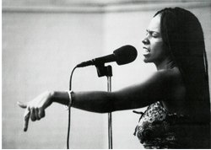
Jessica Care Moore is a poet, producer, activist, playwright and actor, rock star interdisciplinary artist, and CEO of Moore Black Press. She is a five-time Showtime at the Apollo winner; has featured on hip-hop mega-star, Nas' Nastradamus" album and was a returning star of Russell Simmon's HBO Series, Def Poetry Jam. In 1997, she paved her own path and launched a publishing company of her own – Moore Black Press, which has released her first book; "The Words Don't Fit In My Mouth," and several thousand copies. A few years later, she followed up with her second collection of poetry and essays, "The Alphabet Verses The Ghetto."

Moore Black Press proudly published famed poets, Saul Williams and Shariff Simmons; Def Poetry Jam's co-founder, Danny Simmons, NBA basket-ball player, Etan Thomas, activist and poet, Ras Baraka and former Essence Magazine editor and author, Asha Bandele. She is the youngest poet published in the "Prentice Hall Anthology of African American Women's Literature," by Valerie Lee, alongside literary greats, Zora Neale Hurston, Alice Walker, Octavia Butler Maya Angelou and many others.

Jessica was also featured in Essence, Blaze, Source, Vibe, African Voices, Bomb, Mosaic, Good News, Savoy, One World, BE, Ambassador Magazine and others. She voices herself as a strong warrior in the fight against AIDS. She has performed for the United Nations World AIDS Day Commemoration two years in a row. Her innovative and inspiring take on literacy among our nation's youth landed her opportunities to produce several art programs, concerts, and workshops for the National Black Arts Festival in Atlanta, and worked as a facilitator for The Langston Hughes National Poetry Circle Project.

As an internationally respected author and poet she has rocked stages all around the world from Cape Town, Durban, Johannesburg, Berlin, Paris, Holland, England, Scotland and many others. She had a cameo appearance in the award-winning film, "Slam," and is one of the stars of the documentary, "Slamnation!" She is the producer, writer and star of the poetry and music themed show, "SPOKEN!" aired on the Black Family Channel,

http://jessicacaremoore.com/

Justin Phillips (Montreal, Canada)

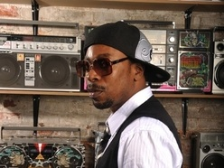
Justin Phillips, aka Dee Shade, is a videographer, recording artists and MC from Montreal. He was formerly a member of Shades of Culture, a Canadian hip hop trio regarded as one of the pioneers of rap music in Montreal.

After completing their fourth tour across Canada, the trio released their first full length CD entitled Mindstate, along with several singles with such artists such as DJ A-Trak. They also released a self-titled “Mindstate” single that aired regularly on Muchmusic, MusiquePlus, BET and MTV.

Dee Shade released his solo album in 2013, The Water Principle, which featured collaboration with hip hop legend Buckshot, and Dee also produced video trailers for the record.

https://www.facebook.com/dshademusic

John Akpata (Ottawa, Canada)

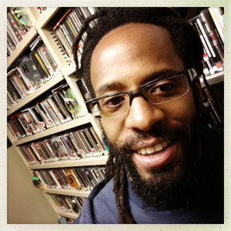
John Akpata is a Spoken Word Artist, Art Educator and Radio Broadcaster from Ottawa. He has won competitions and awards, has toured nationally and internationally, and is a successful recording artist. John is a featured poet in the anthology The Great Black North: Contemporary African Canadian Poetry. He has released five albums of Poetry and Music, and toured nationally and internationally.

Currently John teaches Poetry and Spoken Word Workshop Series at Woodroofe High school in Ottawa, and also was a resident poet at Ridgemont High School.

He is the host of Monday Night Scribes on CHUO 89.1 FM, a radio show dedicated to writers, reciters, MCs and poets. John has live guests, plays Spoken Word recordings, as well as hip hop, reggae and world music.

https://johnakpata.wordpress.com/

Kat Francois (London, UK)

Kat is a well‐known performance poet on the UK and global scene. She was the first person to win a televised poetry slam competition in the UK, winning the BBC3 TV Slam. That gave her the platform to compete in the World Poetry Slam Championship in Rotterdam the following year where she was crowned 2005 World Slam Champion.
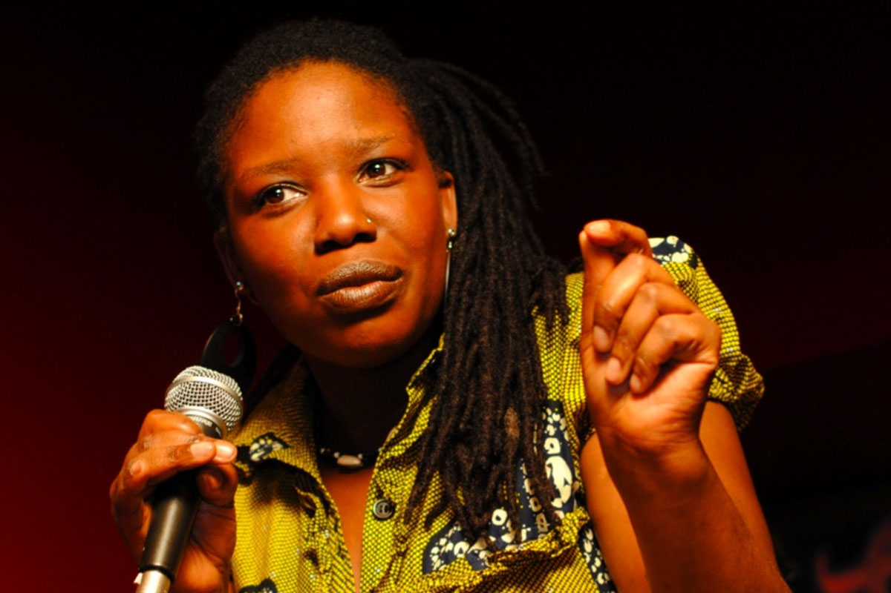
As resident poet at Theatre Royal, Stratford East, London, Kat hosts and organizes a monthly poetry and music night called Word4Word. It was here that Kat, ensuring a bar audience respected poets on stage, grew and crafted a natural talent for asserting herself through comedy. Kat also runs a monthly poetry night at The Poetry Café Covent Garden, INTIMATES. Kat Francois is also an educator and has 20 years experience working with young people as a youth worker, workshop leader and PHSE facilitator. Kat uses poetry, drama and creative writing to reach young people and adults; she teaches in schools, colleges, universities, youth clubs, hostels, pupil referral units, and young offenders institutes.

www.katfrancois.com

Kevan Cameron (Vancouver, Canada)

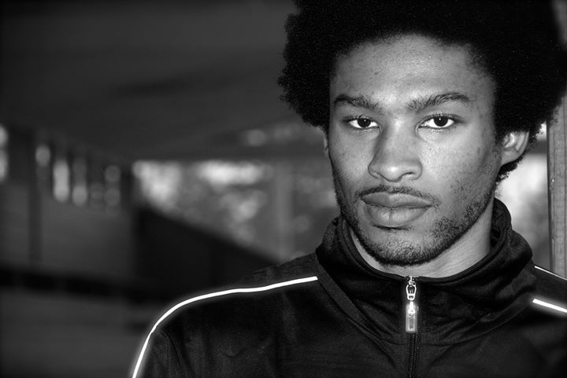
Kevan Anthony Cameron, also known as Scruffmouth is a spoken poet, performer and writer with the ability to condense issues of social justice, knowledge of self, identity, philosophy, history and freedom into creative poems for the page and the stage.

He is a veteran of the North American poetry slam scene and has been published books, journals, periodicals and anthologies. He is creative director for Black Dot Roots and Culture Collective, a group of artists and professionals with the vision to connect the dots of the community through education, creation and celebration of the heritage of peoples of African descent. BDRCC produces the annual Pan African Slam showcase as well as the Hogan's Alley Poetry Festival. He is the co-editor of the landmark anthology, The Great Black North: Contemporary African Canadian Poetry.

http://blackcanadianpoetry.com/
Klyde Broox (Hamilton, Canada)

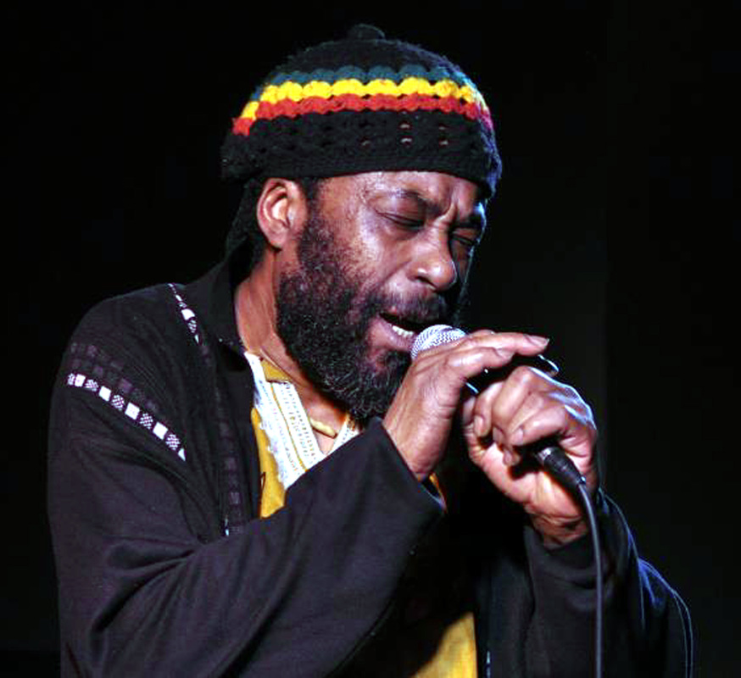
Internationally recognized dubpoet Klyde Broox, (a.k.a. Drum-I) is a Spoken Word veteran. He has done readings, workshops and guest lectures, in Jamaica, North America and Europe. Born in Jamaica, in 1957, Broox taught and performed poetry for sixteen years in his homeland before migrating to Canada in 1993. He now lives in Hamilton, Ontario.

Broox, a 1992 University of Miami James Michener Fellow, won the 2005 City of Hamilton Arts Award for Literature, and the Hamilton Black History Committee’s John. C. Holland Award for Arts Achievement, in 2011.

He hosts PoeMagic, Hamilton’s most popular, poetry performance series. He has published two poetry volumes, Poemstorm, (Swansea, Wales, 1989) and My Best Friend is White (McGilligan Books, 2005), which was selected as the Arts Hamilton/Seraphim Editions Best Poetry Book for 2006. “Steeped in both old and new-world oral and scribal traditions; Broox invites audiences to experience poetry as social communion.”

https://www.facebook.com/klyde.broox

Krystle Chance (Toronto, Canada)

Krystle Chance, is a talented vocalist, songwriter from Toronto primed to launch her career. Recently, she had the opportunity to go to China to sing and judge various music competitions.

Krystle uses her musical gifts to give back to her community, dedicating time to creating and facilitating music and creative writing workshops for Toronto youth. Currently Krystle is working on a musical project called COVERS, a compilation of favorites as interpreted by this songstress.

https://www.facebook.com/KrystleChanceMusic

Kym Dominique-Ferguson (Montreal, Canada)

Kym is a poet born, an actor and filmmaker made, writing his truth on paper since his mid-teens. Upon arrival in Montreal in 2000, he transitioned from writing to performing his poetry via local open mics, college and high school stages across Canada and the US. Kym has performed in Jamaica, Barbados, Montreal, Toronto, Ottawa, and New York.

His company Madpoetix Productions runs a monthly Open Mic series called: MADPOETIX Soirées Intimes, which has run consistently since April 2011. His aim with this series is to focus on quality artistic events. He continues to innovate in working to incorporate different disciplines, like filmmaking and theatre, with poetry.

https://www.facebook.com/madpoetix

​Letecia Rose

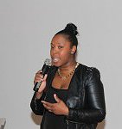
Letecia Rose is currently the Manager of Programs & Partnership at Nia Centre for the Arts She is a youth advocate passionate about empowering youth to become the leaders of their communities. From her experience in community theatre, she uses anti-oppression and popular education techniques to engage the diverse audiences that she works with.

Working the area of equity and diversity, community engagement, and social justice for over seven years as a volunteer, program coordinator, and educational director, Letecia aims to create inclusive, youth-centered learning communities where youth can discover hidden potential, advance their leadership capabilities and foster a passion for the arts.

http://www.niacentre.org/#!staff-letecia/c6zs

Lillian Allen (Toronto, Canada)

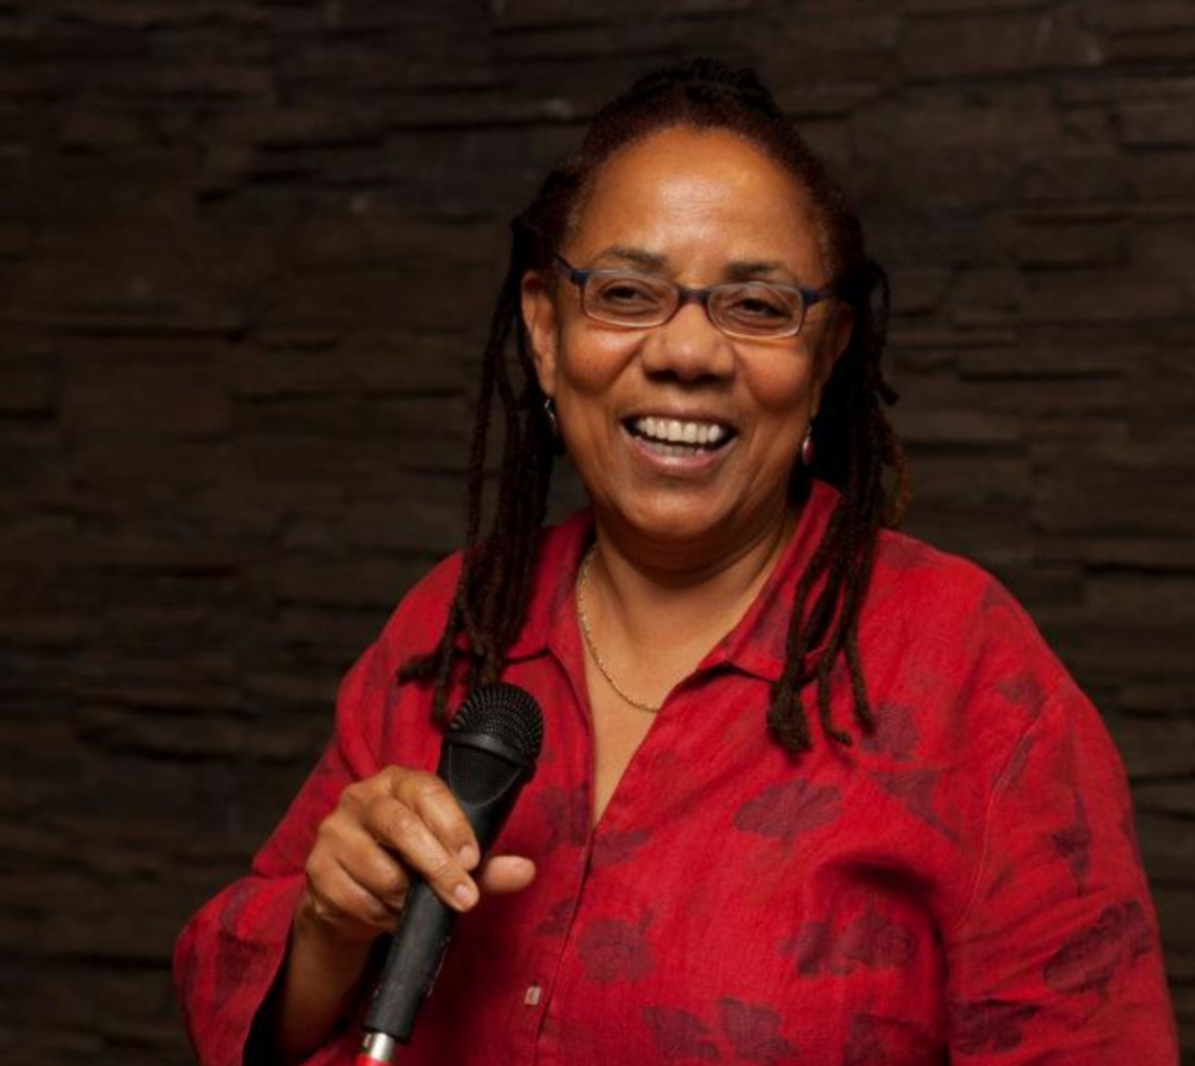
Lillian Allen is a Creative Writing Professor at the Ontario College of Art & Design University in Toronto Canada. Allen emerged from the grassroots in the seventies to become a leading influential figure on the Canadian cultural landscape. She is an award winning artist: “Revolutionary Tea Party” and “Conditions Critical” both won Canadian Juno awards in 1986 and 1988 respectively.

An inspired strategic thinker and cultural strategist, Lillian is an expert on cultural diversity in Canada and has initiated, designed and facilitated the establishment of a number of organizations in various cultural communities. Lillian also initiated such programs as the legendary Fresh Arts and the International Spoken Word Program at Banff Center for the Arts. She co-produced and hosted CBC’s Wordbeat, a national radio show on poetry/spoken word.

Lillian is an innovator in dub poetry, a poetic form drawing from Caribbean language and culture, and manifesting the inherent musicality of words. Often set to music, dub poetry impacted the musical scene across Canada with artists like Toronto’s De Dub Poets - Devon Haughton, Clifton Joseph, and Lillian Allen. By 1993, Lillian was one of the main organizers for the 1993 International Dub Poetry Festival, which included Dub Poet originators and legends, Oku Onuora, Jean Breeze, and Mutaburka, Brother Resistance from Trinidad, Winston Farrell from Jamaica, and from South Africa, Mzwakhe Mbuli. She has continued to champion African Canadian spoken word artists and their central role in shaping Canadian Literature and popular culture, and instigating social change.
www.lillianallen.ca/
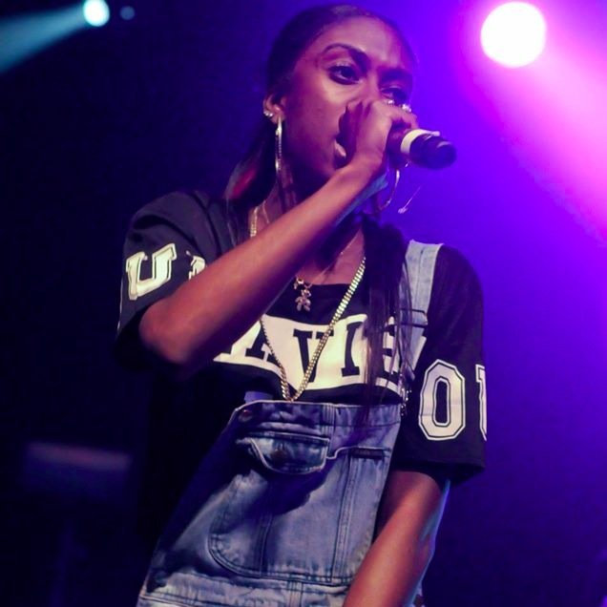
Lola Bunz (Toronto, Canada)

An MC, Spoken Word Artist, actress and community Leader, Funmilola ‘Lola’ Lawson, aka LolaBunz is making big strides in representing female MCs in Toronto in her hope to be a voice for the unheard. Born and raised in Jane & Finch, LolaBunz brings a different approach, style and vocal ability. Introduced to hip-hop by her older brother, she soon grew to love the Art of Hip Hop and became inspired to create her own brand of it. Musical influences include female MCs Eve, Michie Mee, and Remy Ma, as well as DBlock, LOX, Jadakiss and Styles P.

https://twitter.com/thelolabunz
Louise Profeit-Leblanc (Wakefield, Canada)

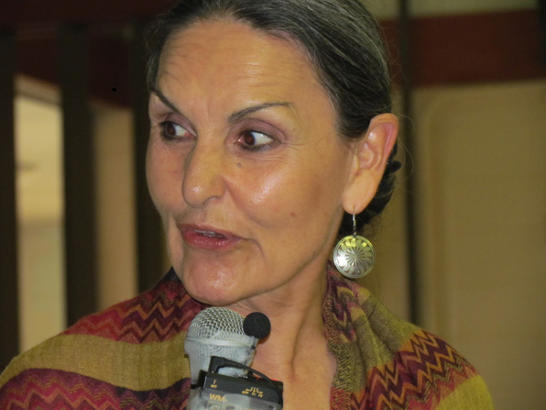
Louise is from the Nacho Nyak Dun First Nation in northeastern Yukon. She has come from a long line of storytellers and is now the keeper of many of these stories of the ancient and not so distant past. For 15 years she worked with her people all over the Yukon to ensure that the oral histories and stories of the First Nations people were recorded and transcribed for posterity.

Cofounder of the Yukon International Storytelling festival, Yukon and the Society of Yukon Artists of Native Ancestry, Louise has attempted to ensure the voice of her people is heard and will be protected for the future generations. This voice and information is a gift that her people must share for the betterment of the world.

She was Coordinator of the Aboriginal Arts Secretariat at the Canada Council for the Arts in Ottawa, where she has migrated with her husband and grandson to serve the needs of many Aboriginal artists of Canada and abroad. In 2006 she wrote a piece for the New Media Arts program at Banff and has also participated as a guest artist, storyteller, choreographer, and film script writer. Louise currently lives in Wakefield, Quebec, and continues to work to ensure the voice of her people is heard and will be protected for the future generations, and shared for the betterment of the world.

https://www.facebook.com/louise.profeit

Mahlikah Aweri (Toronto, Canada)
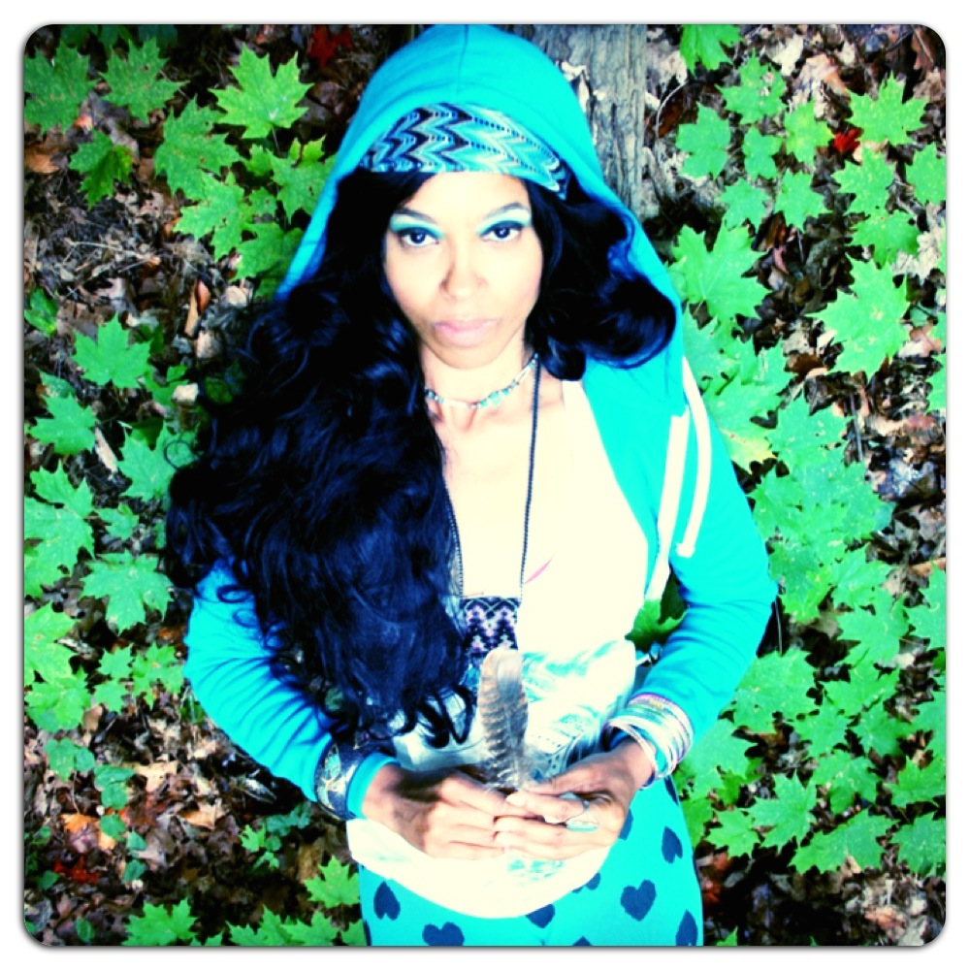
Mahlikah Awe:ri , Enml'ga't-Saqama'sgw, Walking Woman, is a First Nations drumtalk-poetic-rapologist; musician; hip hop MC; arts educator; radio show host; artivist, curator and recently appointed Deputy Executive Director of the Toronto Centre for Community Learning & Development in Regent Park. Based in Toronto, with Nova Scotian Roots. Mahlikah is a founding member of Red Slam Collective Indigenous Hip Hop Movement, 2013 nominees of the inaugural TD Diversity Arts Award. In 2011, Awe:ri released the EP Serpent’s Skin; currently published in five literary anthologies, she was nominated for the KM Hunter OAC Literary Arts Award in 2013.

https://myowenamyokra.wordpress.com/tag/mahlikah-aweri/

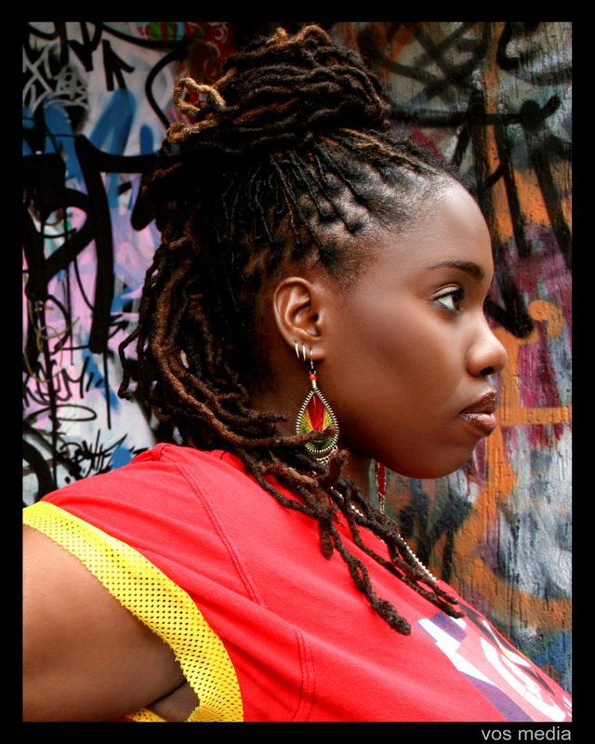
Motion (Toronto, Canada)

An award-winning emcee/poet, playwright, screenwriter & Hip Hop artist, Motion’s fusion of word, sound and drama is a potent mix of the ancient to the futuristic. Her lyrical agility has taken her to the stages of Manifesto Jamaica, the Urban Music Awards, CBC Television and HBO Def Poetry Jam, and she opened for renowned artists like Mos Def, Wycelf Jean, Talib Kweli, and Jill Scott.

Lauded by Now Magazine as a “multi-talented, truthful artist,” Motion flipped the page of Canadian literature with Motion In Poetry. A second book, 40 dayz, was published by Women’s Press in 2002, and is an exploration of her journey as woman, mother, lover and world citizen.

She wrote and produced the play Aneemah’s Spot, which won a 2012 RBC Arts Professional Award, which recognizes “the work, craft and dedication of an emerging arts professional”. The play debuted at the Rock Paper Sistaz festival in Toronto, as well as at the famed Luminato event, Summerworks Festival and Young Centre for the Arts. Motion is currently playwright-in-residence at Obsidian Theatre Company. Inspired by her work with the legendary Fresh Arts movement, she continues developing emerging talent in creative spaces such as St. Alban's and AMY Project.

http://www.motionlive.com/

Mtaalamu “Taalam” Acey (Tampa Bay, USA)

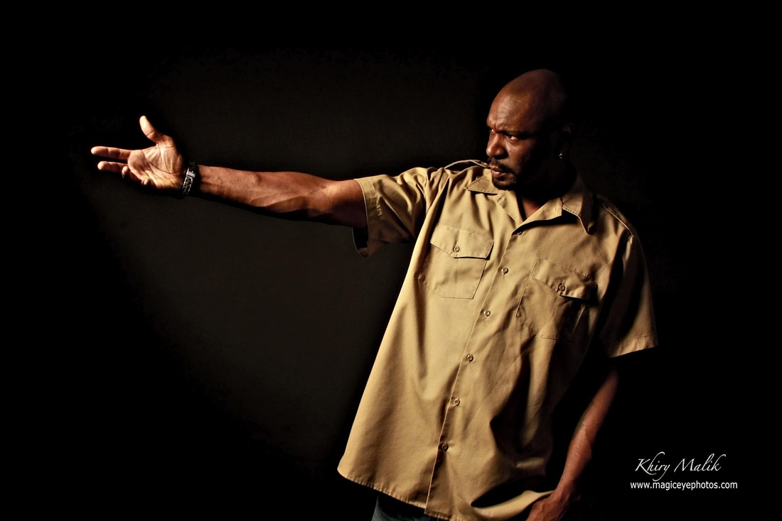
Taalam, a child of the Newark Rebellion, was raised by a single mother who was a member of the famed writer and activist Amiri Baraka’s community organization. Acey is an independent artist whose work has been featured frequently on TV One and was selected as the original "number one thing you need to know about" on BET's countdown show, "The 5ive." BET has featured roughly a half dozen segments featuring Taalam Acey. The Newark, NJ native’s poetry has appeared in Essence Magazine and Susan Taylor, the magazine’s Editor Emeritus, personally invited Acey to perform for an audience of 6,000 at The Essence Music Festival in New Orleans.

Taalam was honored to be a guest of Congresswoman Maxine Waters for the Congressional Black Caucus' 2007 & 2008 "Young Gifted and Black" panels. He has shared his work in several countries and approximately one hundred schools of higher education; including the esteemed Graduate School of Education at UC Berkeley, where he delivered a lecture on contemporary Spoken Word. He was featured on "Lyric Cafe," NPR's (National Public Radio) TELL ME MORE and has recorded fifteen CDs and authored four books. Additionally, films that include his work have garnered an Audience Award (2002) and a Special Jury Prize (2006) at the Sundance Film Festival. He was featured in an acclaimed Radio-One London slam poetry documentary and Marc Smith, the founder of slam poetry, used Acey's work in his definitive book. Taalam currently resides in Tampa Bay, Florida.

http://taalamacey.blogspot.ca/

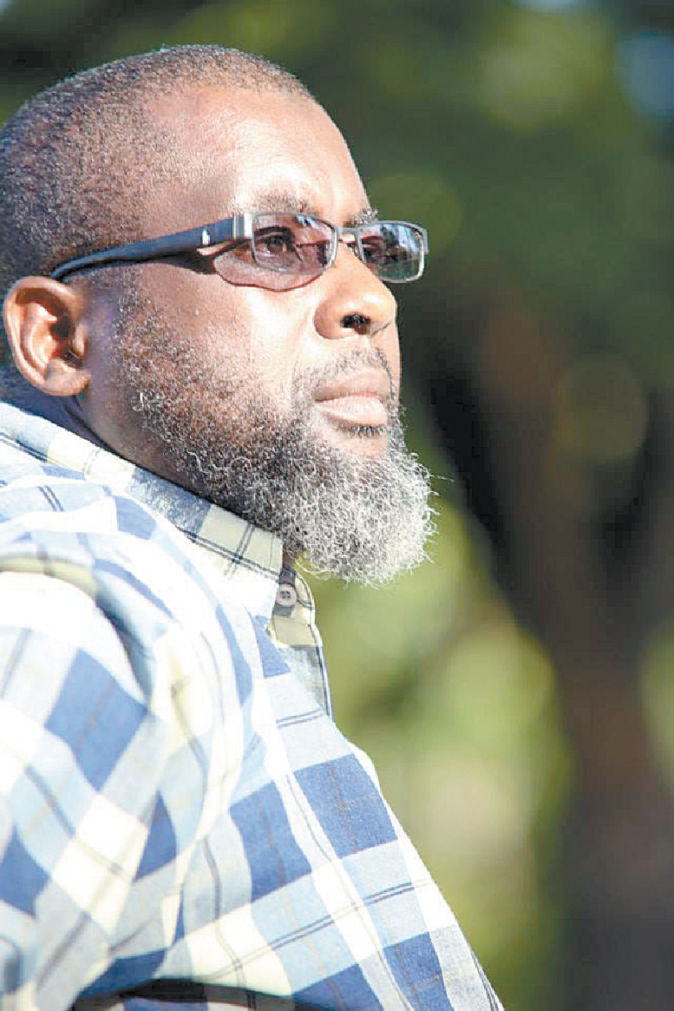
Mtima Solwazi (Trinidad & Tobago)

Mtima Abdul Ghany Solwazi utilizes spoken word as a tool for therapy, social activism, civic engagement, arts education, and literacy development. He is also an example of resilience in how spoken word can engage youth at risk. He left Belmont Boys’ Secondary, and was involved in street gangs.

Today, Mtima holds a Bachelor of Sciences with honors in Psychology with Minors in Sociology and Criminology from the University of the West Indies, St. Augustine Campus, and a Certificate in Social Work from University of the West Indies. He is currently pursuing his Masters of Sciences in Sociology.

Mtima has been actively involved in community development, working with disenfranchised youth throughout Trinidad. He is the recipient of several community awards for his work with youth, including Recognition in Contribution towards Youth Development, Achievement and Contributions to the Community in Literary Arts, and National Youth Award (Ministry of Sports & Youth Affairs).

Mtima conducts workshops with several institutions and NGOs, and has been employed with the community organization Servol since 2001 in it’s Adolescent Development Programme and as a counselor attached to the Healing Team. He also coaches and mentors trainees who continue to be successful at the National Library and Information System (NALIS) annual verse-reading festival for primary and secondary schools in recognition of National Poetry Day, 15th October. A published poet, he is Editor-in-Chief of ROOTS ( Reflections of Our Oral TraditionS), a bi-monthly newsletter and annual magazine, host to annual poetry slams, Coordinator of CASCADOO Caribbean New Voices International Festival of Spoken Word, and President of The Poet Society of Trinidad and Tobago.

https://cascadoo.wordpress.com/mtima-solwazi-bio/

OpenSecret (Toronto, Canada)
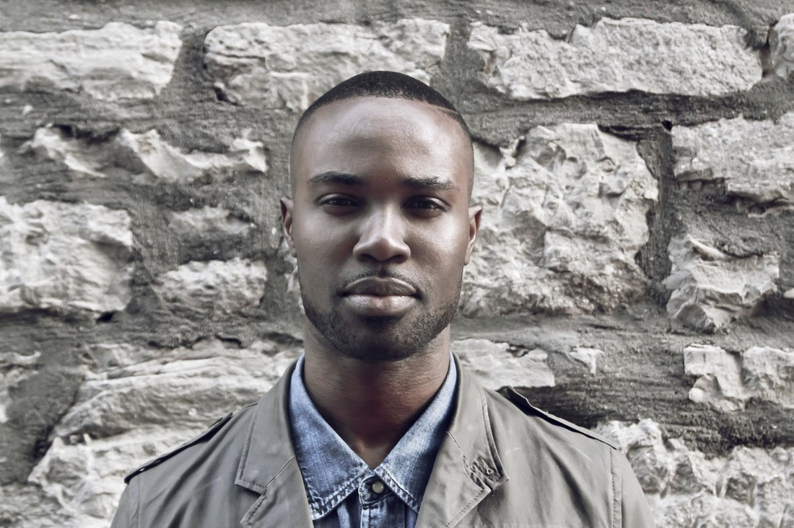
Born in Nigeria, and raised on three different continents, Ikenna “OpenSecret” Onyegbula has been a spoken word performance poet for five years, having begun competing locally in the Ottawa Poetry Slam scene in 2007.

His work focuses on an array of diverse topics and subject matters from historical biographies to social justice issues, utilizing performance to get into the crux of an ever changing set of circumstances in order to challenge audiences to engage with a vast spectrum of emotions. He has won numerous accolades for his work and has performed all over Canada, the United States and in Europe. He was recently crowned World Slam Champion in the 2014 international event in France, and is also a Canadian slam champion.

As a member of the four member spoken word troupe, The Recipe, Ikenna has been able to further develop his craft and enhance his passion for performance poetry. He has also self published four poetry chapbooks, Until, September and If Prayers Were Answered I and II and runs performance and writing workshops in Ottawa, Canada, both for youth and adults. He has a passion for community organizing and event promoting and is currently working as an organizer of the YouthCan Slam, Canada’s national youth poetry festival.

http://opensecretthepoet.com/

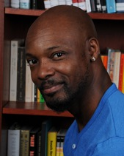
Osei “Manchilde”Alleyne (Philadelphia, USA)

A joint Africana Studies and Anthropology student at the University of Pennsylvania, Osei holds an MA in Communications from Temple University and a BA in History from Concordia University, Montreal.

As a Hip Hop and Spoken Word artist, Manchilde has shared stages with the likes of The Roots and Mos Def, and released several records, initially as part of famed Montreal hip hop group, Butta Babees. He featured in a number of videos, and continues to release records, including Pheonmenlogie and single song/video “Full Moon Over Ghana.” Osei is interested in tracing the oral tradition in urban music through forms such as Reggae and Calypso back to original griot traditions of West Africa. Osei has designed and taught university courses in Hip Hop, Media and Cultural Communication and presented at conferences on representations of technological futurism and human destiny in popular culture. Having lived in Trinidad & Tobago, Canada and the US. Osei hopes to apply his international experience to his doctoral work in the Department of Africana Studies at University of Pennsylvania.
http://www.reverbnation.com/manchildemovement
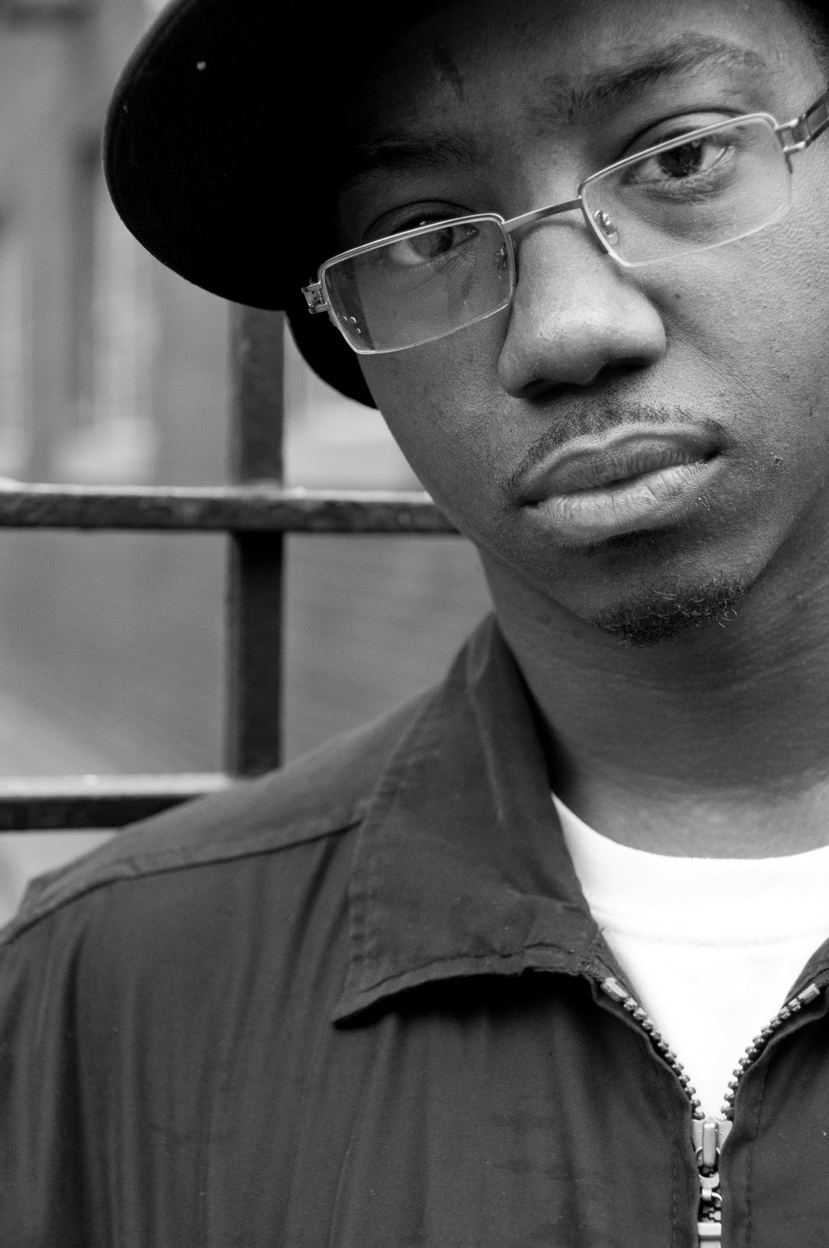
Quentin VerCetty (Toronto, Canada)

Quentin VerCetty is an award winning contemporary griot - storyteller whose practice focuses on artivism and the empowerment in controlling the narrative of your own story for today and the future. Having a background adolescence that was shaped by affiliations with street gangs, drug trafficking and various illegal activities, he now uses his experiences to create art using film, poetry, short story parables, drumming, painting and 3D digital art rendering, to inspire and provoke social change.

Quentin is an avid chess advocate and teaches the game to children, youth and adults as a method to overcome circumstances and build for the future. He has spread his message of arts as a tool for social change in places like London, Dubai, Port-au-Prince, Cape Town, Kingston, Havana and around the United States and Canada. As a recent graduate of Ontario College of Art and Design University he hopes to continue work with youth and different communities internationally.

http://www.vercetty.com/

Rachael Collymore (Trinidad & Tobago)
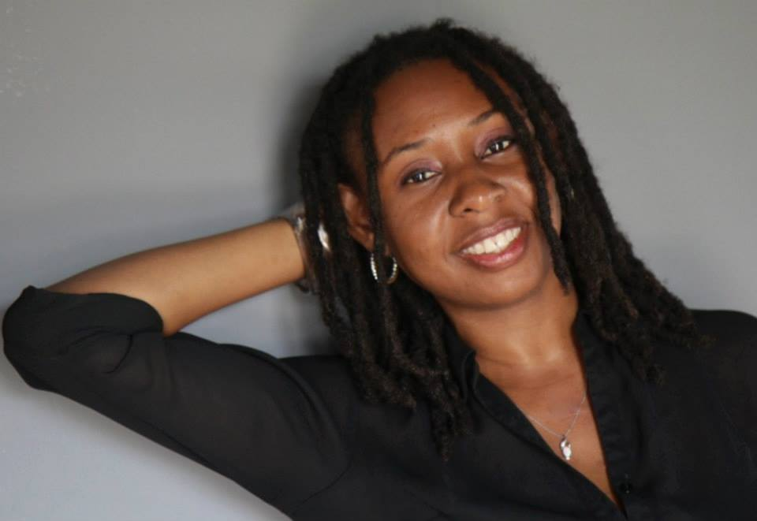
Rachael Collymore is the founder of Poetic Vibes which serves as a promotional and events-based organization, dedicated to creating a platform for artisans.

As a poet, Rachael has used this medium to channel her creative energies to raise the level of awareness and standard of the arts in Trinidad & Tobago. She is a member of the Circle of Poets of Trinidad and Tobago, a Public Relations practitioner and Events Coordinator. She has written for CPC Women in Business, Arc Magazine and other publications.

https://www.facebook.com/poetic.vibes/info?tab=page_info

Randell Adjei (Toronto, Canada)

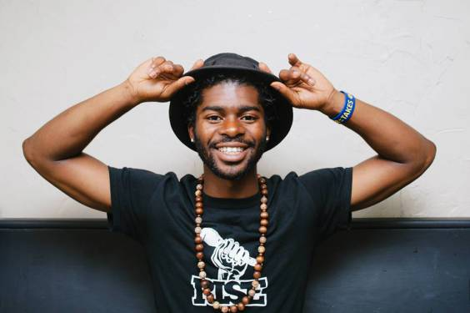
Randell Adjei is a spoken word Edutainer and Artivist who uses the power of words to reach people through “edu-tainment”. He is also the founder of the Citywide movement Reaching Intelligent Souls Everywhere (R.I.S.E Poetry).

Randell believes that there are a lot of issues in our society that need to be addressed, and he uses his art to educate. Many of us are lost in society but we are all responsible for one another’s growth. A former juvenile delinquent, Randell has been incarcerated, suspended, robbed at gunpoint, and almost lost his life when he was stabbed in the back and elbow at age 17. When he learned he could turn his struggles around to inspire others through his talent, things began making sense.

Randell is a recent recipient of the Identify & Impact Street Level Advocate Awards by the Toronto Youth Cabinet & the Yinnergy Appreciation award from members of the Malvern Y.O.W community. His mission is changing the vibration of the world bringing together the Unity in Global Community.

http://riseedutainment.com/site/

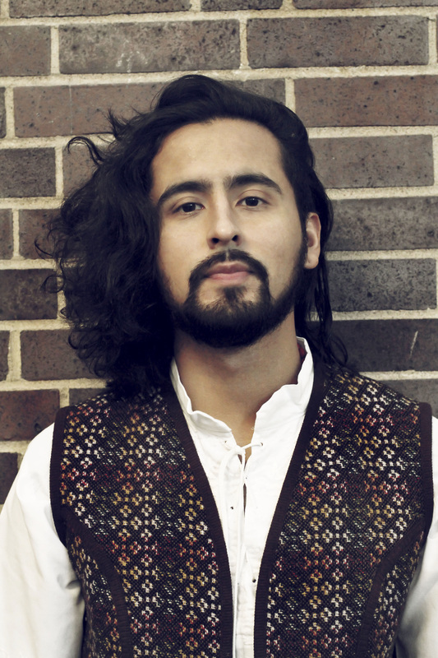
Sergio Guerra (Gatineau, Canada)

Sergio Guerra aka "Hyf the GypsySun" is a Salvadorian-born writer, poet/ MC, and producer., and one of the organizers of the Urban Legends poetry slam in Ottawa. Based out of Gatineau, on the Quebec side of Ottawa River, he is part of hip-hop MCs that founded Nationless Mind Records in 2012. More than a label, Nationless is building a community of support for artists who are typically on the cultural fringe. Its members create music that is political, powerful and relevant.

His work explores themes of identity, cultural intersections, Islamic revival, and the reclamation of ancestral roots for displaced peoples, Hyf fled the civil war at the age of seven to arrive in Canada. He has appeared on a number of records and released several videos, most recently “Sweet surrender.”
www.nationlessmind.com

Shauntay Grant (Halifax, Canada)
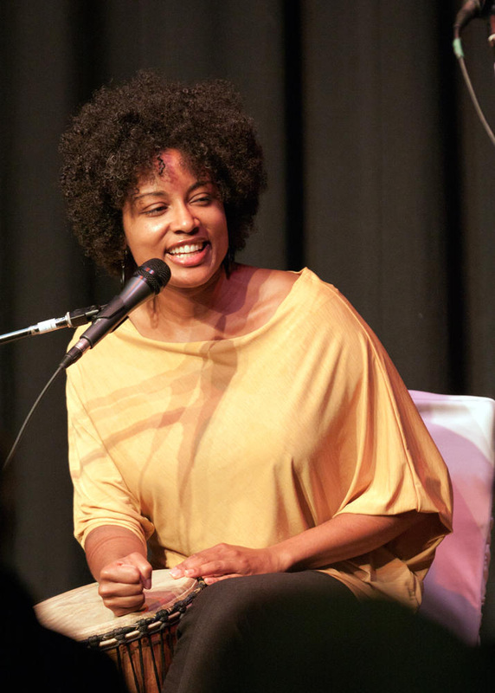
A dynamic writer and storyteller, Shauntay's work has earned her invitations to present at local and international events including Canada's national Word On The Street festivals (Halifax, Toronto, Kitchener), Ottawa's Versefest, the Vancouver Writers Fest (where she was the 2010 Writer In Residence), Toronto's Luminato Festival, Australia's National Young Writers’ Festival, Jamaica's International Maroon Convention, and the 10th Anniversary Launch of Amistad in Havana, Cuba.

Shauntay's homegrown artistic practice embraces African Nova Scotian folk tradition as well as contemporary approaches to literature and performance. She is an award-winning author who has written and published in several literary genres, and as one of Canada's leading practitioners of spoken word performance she was awarded a Poet of Honour prize by Spoken Word Canada at the 2010 Canadian Festival of Spoken Word. Shauntay hosted CBC Radio's National Poetry Face-Off broadcasts in 2008 and 2009. She was the literary arts mentor for the 2011 Canada Games National Artist Mentoring Program, and she regularly instructs youth and adults of all ages in the art of creative writing and spoken word performance.

http://www.shauntaygrant.com/bio
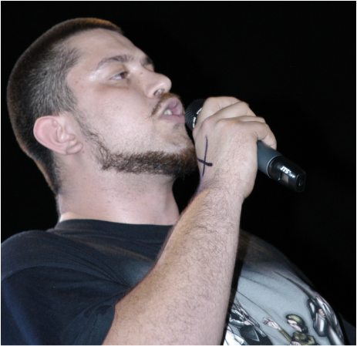
Spin (Toronto, Canada)
Poet. Arts Educator. Workshop Facilitator. Revolutionary. Youth Advocate.
Keeper of the sacred Cholq’ij calendar of the Cosmovision Maya. SPIN was born in Guatemala in the midst of a brutal 36 year war. Politicized by the experience of becoming a refugee the day after his eleventh birthday. Raised with excellence by his mother. SPIN embarked on a journey to vindicate their suffering & learn his history and that of the country where his innocence was stolen by American intervention. To date SPIN has performed in 7 countries and over 20 cities including sovereign indigenous territories in the north. Currently SPIN delivers arts education workshops to young offenders and is part of the first ever Canadian Hip Hop curriculum. He is also a part of a capacity building project with teachers and the arts in the TDSB. As well, he is the 2015 Toronto Poetry Slam Grand Champion.

http://www.spinelpoeta.com/
Evanson (Montreal, Canada)

Tanya Evanson is a poet, performer, producer and educator. Author of six artist books of poetry, most recently Love Letter to Anatolia (2012), her writing has appeared in literary journals and anthologies, including the recent WomanSpeak - A Journal of Writing and Art by Caribbean Women (2014) and The Great Black North - Contemporary African Canadian Poetry (Frontenac House 2013).

Fusing concentrated language with music in spoken word performance since 1996, she has released three studio albums including Language for Gods and the award-winning videopoem Almost Forgot My Bones.

She is director of Spoken Word at The Banff Centre, and also directs ANU live interarts and Sema Space meditation sessions. She lives multilingually in Montreal, Quebec where she is currently guest editor for the fall 2015 issue of ARC Poetry Magazine and at work on a new album, short film and poetry manuscript entitled Bothism.
http://www.mothertonguemedia.com/info_bio.htm

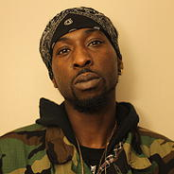
Teddy Osei (Toronto, Canada)

Teddy Osei is a rapper and visionary who displayed his leadership in a variety of capacities within the work of the Nia Centre and the “Artists for Recreating Opportunities” roster. He is a hard-working artist who forms part of the hip hop group, Griotz Road.

http://www.niacentre.org/#!afro-highlight-of-the-month/c1ae3

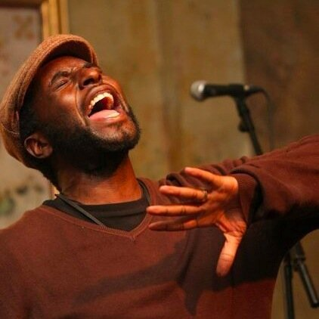
Tuggstar (Toronto, Canada)

Tuggstar is a motivational poet and coach, passionate about telling poetical stories and inspiring others to achieve their goals. He has a self-published poetry book entitled ‘’The Way of the Word,” released his debut ‘The Africa E.P: From Here to There and Home. In 2005 he became the first national columnist to spoken word, hosting the ground breaking New Word Order in New Nation newspaper. His efforts earned international media attention.
Tuggstar conducts mastermind groups for entrepreneurs, business men and women, and people seeking to find inspiration to achieve their goals. Today as well as still pursuing poetry, Tuggstar conducts engaging inspirational and motivational workshops, as his focus is to use his skills to inspire more people to achieve their goals.

https://www.facebook.com/togobo.tuggstar

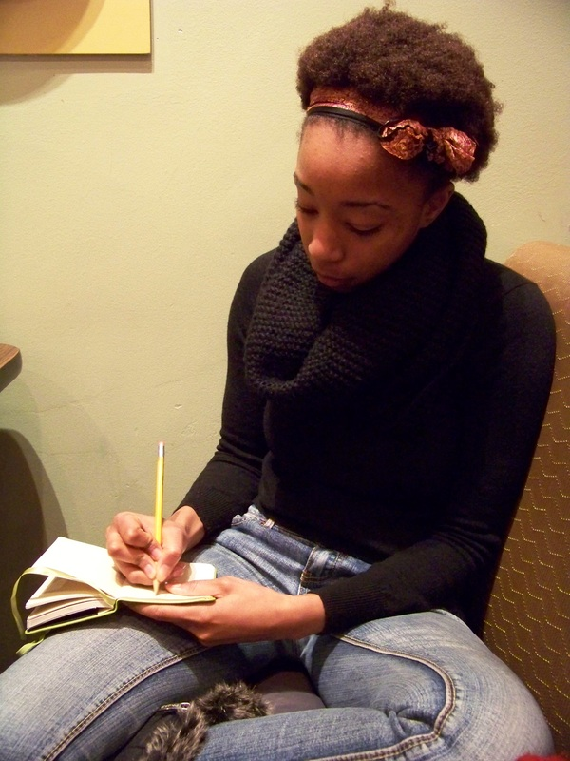
Whitney French (Toronto, Canada)

Whitney French is a writer based in the Toronto area although she does most of her eating, sleeping and actual writing in her hide-out north of the city, Bradford. Her interests include reading and writing, and she has worked as a Production editor at descant, one of the top literature journals in Canada. She graduated from Concordia University with a BA in Creative Writing and teaches writing to youth in Toronto. She is the author of the new poetry collection, Three Cities.

https://www.facebook.com/WhitneyFrenchWrites

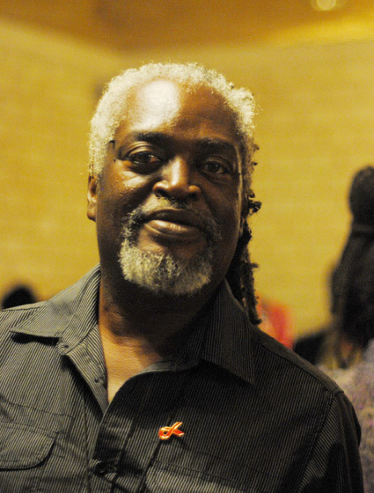
Winston Farrell (Barbados)

Winston Farrell holds a Master in Theatre and Development Studies from the University of Leeds. As a poet Farrell has toured extensively and has benefited from a number of Artist/Writer in residence programmes

Winston has also released recordings of his rhythm/dub Poetry – ‘Lion on the Loose’ and ‘Earth Spirit’, Red Ribbons, and his latest release, ‘I am standing up’, is featured on James Lovell’s album.

Winston’s published collections include, ‘Busting the Blues’, and ‘Call of the Quarter Master’. He is the winner of the Prime Minister’s Award for poetry as well as a third and first place recipient of the Frank Collymore Literary Endowment Award.
https://www.facebook.com/winston.farrell.1

Yasus Tafari (Kingston, Jamaica)
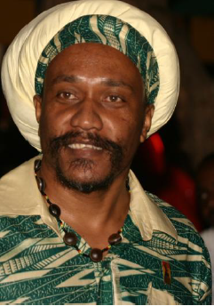
Jamaican-born reggae artist and dub poet Yasus Afari’s signature poetic event, Poetry in Motion, celebrated its 10th anniversary in February 2013, as the annual rendition of Jamaica’s rich poetic heritage showcasing leading poets and entertainers. In 2011, he established the Jamaica Poetry Festival in Kingston, and remains the current Director.

Deeply rooted in his Rastafarian faith, Afari is not only a dub poet, but also an author, philosopher and reggae artist. He attended the Parliament of the World’s Religions in Melbourne, Australia, as an Ambassador of the Council for the Parliament of the World’s Religions to make a presentation on “Rastafari: The Livity of Spirituality.”

As one of the original "Christian Souljahs," Afari helped engineer the cultural renaissance in reggae and dancehall music/culture, alongside other Rastafarian artists such as Garnet Silk, Tony Rebel, Luciano, Buju Banton, and Capleton. In the mid-90's, he teamed up with reggae legend Pablo Moses and Dele Mandeyah to form Fathers Of Africa, which toured schools in Jamaica, and the United States.

Along with touring world-wide, Afari has recorded with the likes of Black Uhuru, Toots and The Maytals, Freddie McGregor and Beres Hammond, and his poem “Brand New World,” appeared on the Grammy-nominated Black Uhuru album, Strong. He has eight albums of Poetry and Music, including the recent, “Public Secret,” and has authored two best-selling books; ‘Overstanding Rastafari – Jamaica’s Gift to the World’ and the ‘Eye Pen’ anthology.

Yasus is the Rastafari Ambassador to the Parliament of the World’s Religions and currently short listed as Jamaica’s Poet Laureate (the first since Jamaica’s Independence) and was recently nominated for a UN Fellowship Programme for People of African Descent. More recently, Afari has been travelling the world to share his world views through his poetry, working in schools, colleges, community groups, universities and prisons, exploring ways to share a better ‘overstanding’ of black history, while supporting ways for communities to live and work together in our increasingly plural societies.

www.yasusafari.com
NORTHERN GRIOTS NETWORK ORGANIZATION PROFILE

Mission

The Northern Griots Network (NGN) is a not-for-profit, national collective of culturally diverse artists and presenters that supports and develops Canadian spoken word poetry, and promotes the cultural values of the African griot tradition. Formed in 2004, the NGN is particularly committed to increasing opportunities for African Canadian spoken word poets in Canada, especially in terms of touring and performing.

A griot (gree'-oh) is a storyteller in traditional West African Culture who preserves the oral history of her/his village. Griots are revered orators who memorize important events in a village's history including births, deaths, marriages and battles, and embody the collective memory of the village. A griot ensures that the community has the perspective of the past as well as the news of today upon which to base its decisions. A griot can speak and/or sing their stories, often to musical accompaniment, and entertain while drawing upon a history passed from generation to generation, from griot to griot.

The NGN focus includes:

- History/Heritage (understanding of the griot tradition, especially as manifest in African Canadian and culturally diverse artists who have laid the groundwork for spoken word poetry in Canada)
- Communication (nationally and internationally, amongst a growing network of culturally diverse spoken word presenters and artists, as well as artists in a range of disciplines, as well as community workers and leaders)
- Artistic Excellence (assistance for artists to develop their skills and careers through performance opportunities and developmental workshops)
- Education (helping artists access opportunities to learn about arts education)

Objectives

The objectives of the NGN were originally articulated in 2004 as follows:

- To share information in order to increase opportunities for poets to travel and perform
- To assist in arranging international performances by linking with promoters of spoken word series and festivals, and other events in the US, Caribbean, Africa, and elsewhere
- To establish collaboration for promoting, distributing, and retailing pets’ products
- To serve as a resource for poets for information concerning copyright, grant application writing, self-management, media exposure, fair compensation, and other practical topics.
- To advocate for increased hiring, promotion, and retention of African Canadians in Canadian cultural agencies, and assist agencies in consulting diverse communities.
- To develop and implement programs like school tours, poetry workshops, mentoring
- To establish an urban spoken word summit/festival, including recognition of achievements

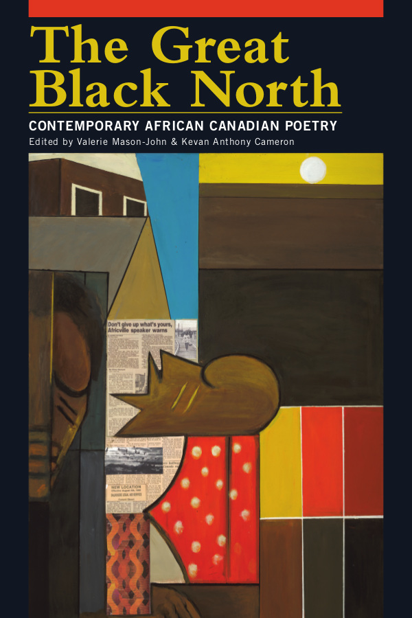
SELECTED RESOURCES

Black Voice—Context and Subtex, Lillian Allen, Prairie Fire, Winter 2014, Volume 35, number 4, http://www.prairiefire.ca/current-issue/

The Great Black North, Contemporary African Canadian Poetry 2013, Edited by Valerie Mason-John and Kevan Anthony Cameron, Frontenac House, 2013
http://blackcanadianpoetry.com/
http://frontenachouse.com/dd-product/the-great-black-north/

Odysseys Home: Mapping African-Canadian Literature, George Elliot Clarke, Toronto: University of Toronto Press, 2002.
http://canadianpoetry.org/volumes/vol54/andrews.html

Spoken Word from the North: Contesting Nation,
Politics, and Identity, Karen Flynn and Evelyn Marrast, Wadabagei Journal, Vol. II, No. 2, Spring/Summer 2008
http://caramfound.org/images/Wadabagei_Journaol_Vol_11_2_2008.pdf

T-Dot Griots: An Anthology of Toronto's Black Storytellers. Richardson, Karen and Steven Green, eds. 2004. Victoria, BC: Trafford Publishing
http://www.torontopubliclibrary.ca/detail.jsp?Entt=RDM186041&R=186041

The Real Story of the CFSW, Anthony Bansfield, RevWord, 2013
https://nthdigri.wordpress.com/real-story/

My Life with Poetry slams, Dwayne Morgan, Up From The Roots, 2014
http://dwaynemorgan.ca/blog/2014/02/26/my-life-with-poetry-slams/

ACKNOWLEDGEMENTS

We acknowledge and thank the following for their work and support for the South-North Griots Summit:

Our Coordinating Committee – Motion, Eddy, Dwayne, Anthony – and our teammate Monique Fuller, all of whom helped compose this Program. And to Dianne , Queen , Darleen , Afiwi, David, Sebastian, George, Lillian, Kevon, Kym, Tanya, Ikenna, El, and the many other advisors and collaborators who helped make the Summit happen. And to funders, supporters, partners:
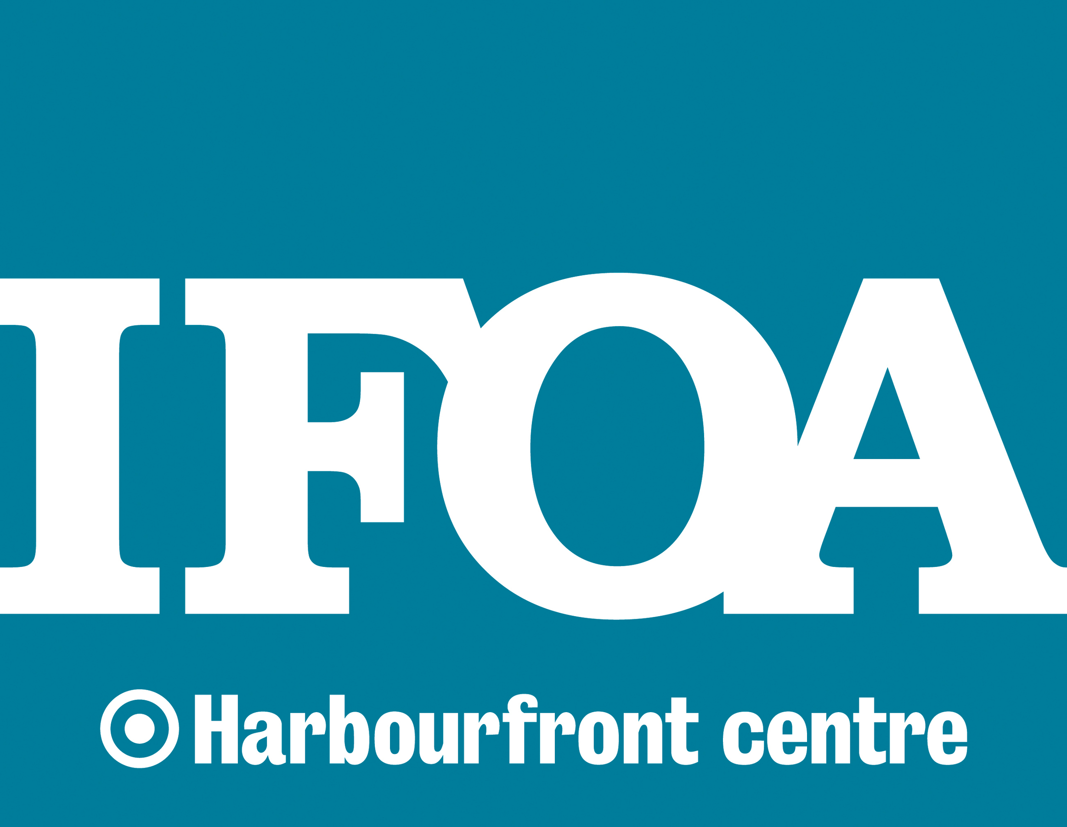

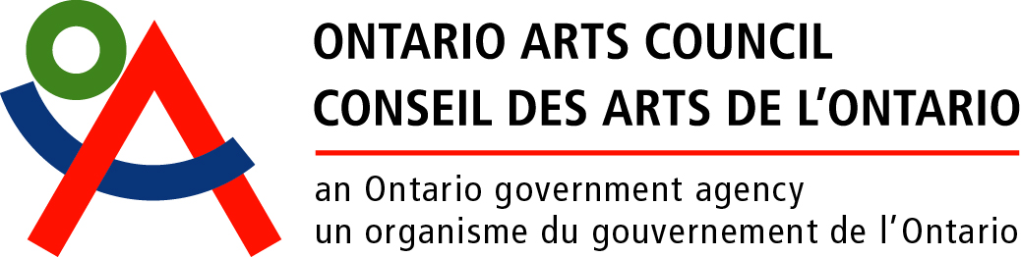

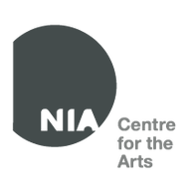
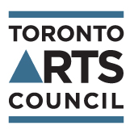

NOTES

NOTES

NOTES

